## **OpenEuler RISC-V Xfce之Settings**

**M anager功能测试-1**

**1 、准备阶段**

### 运行OpenEuler RISC-V

1 ./run.sh

run.sh内容

-kernel Image \

-append "loglevel=3 swiotlb=1 console=ttyS0 rw root=/dev/vda1" \

-drive file=openEuler-22.03.riscv64.qcow2,format=qcow2,id=hd0 \

-object rng-random,filename=/dev/urandom,id=rng0 \

-device virtio-rng-device,rng=rng0 \

-device virtio-blk-device,drive=hd0 \

-device virtio-net-device,netdev=usernet \

-netdev user,id=usernet,hostfwd=tcp::12055-:22 \

-device qemu-xhci -device usb-tablet -device usb-kbd

-vga std \

-smp 8 -m 4G \

-display sdl

-machine virt \

-nographic

qemu-system-riscv64 \

#!/bin/bash

1

2

3

4

5

6

7

8

9

10

11

12

13

14

15

16

登录OpenEuler RISC-V

1. 用户名：root
2. 密码：openEuler12#$

运行Xfce4桌面

1 startxfce4

Xfce4桌面启动后，qemu视频输出窗口应为

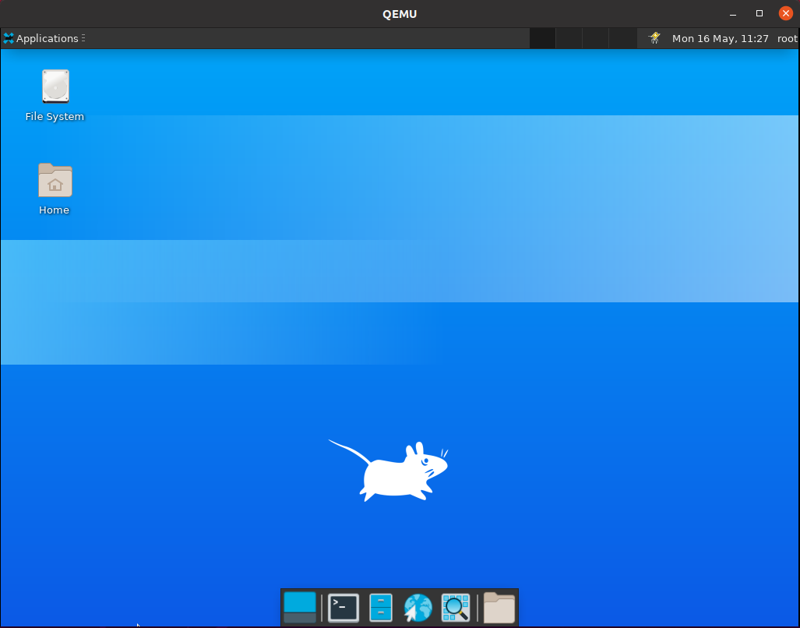

**2 、Appearance功能测试**

### 点击顺序：Applications->Settings->Settings Manager

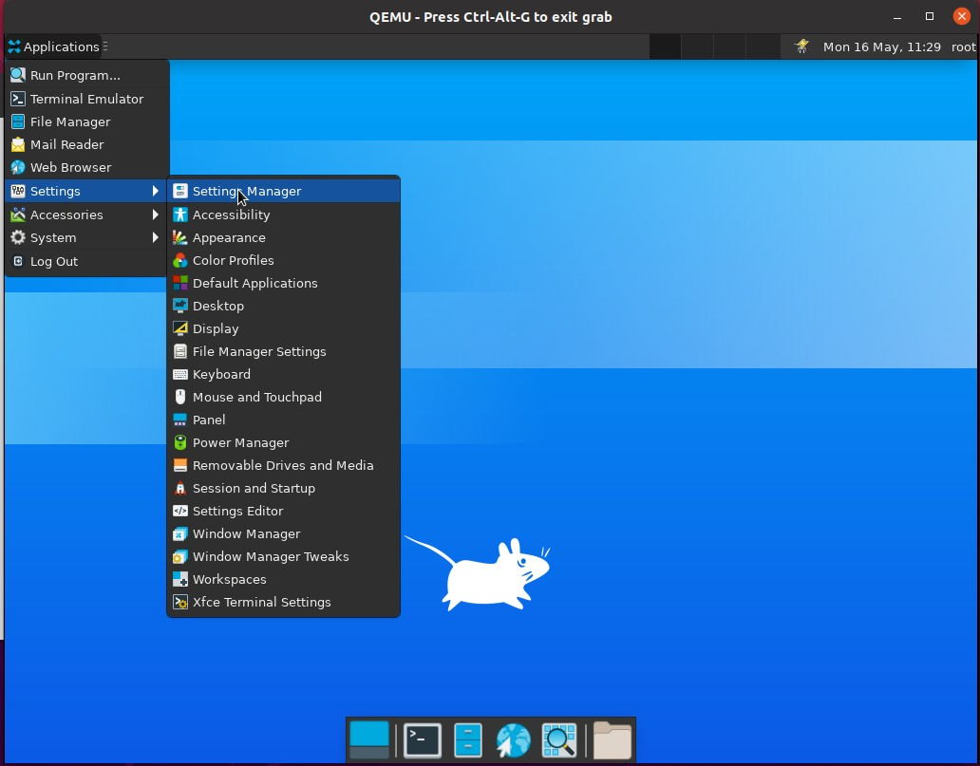

进入如下界面

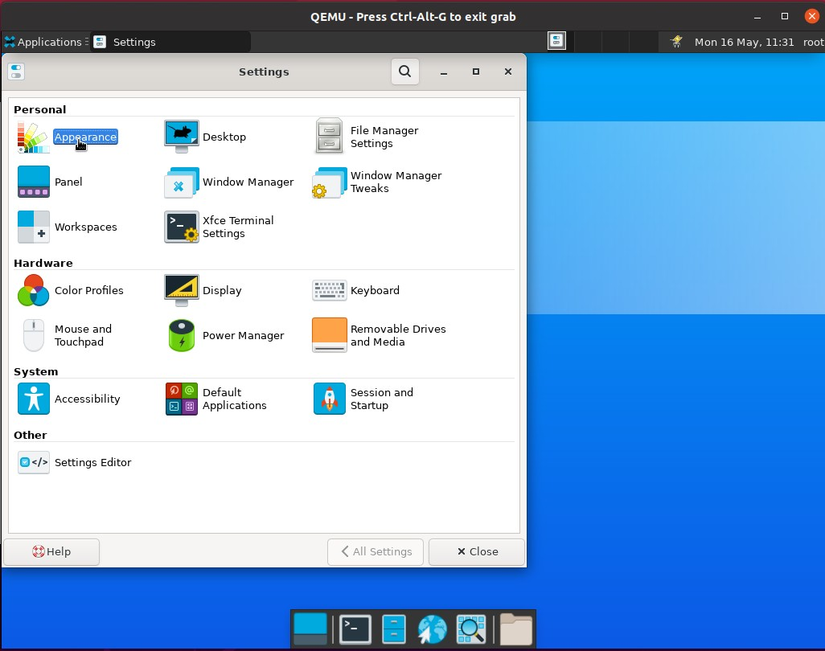

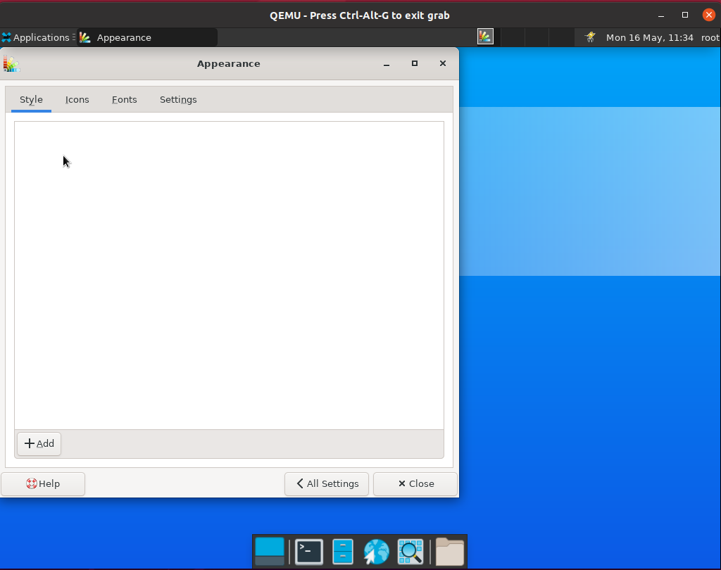双击"Appearance"，进入如下界面

单击“Add”

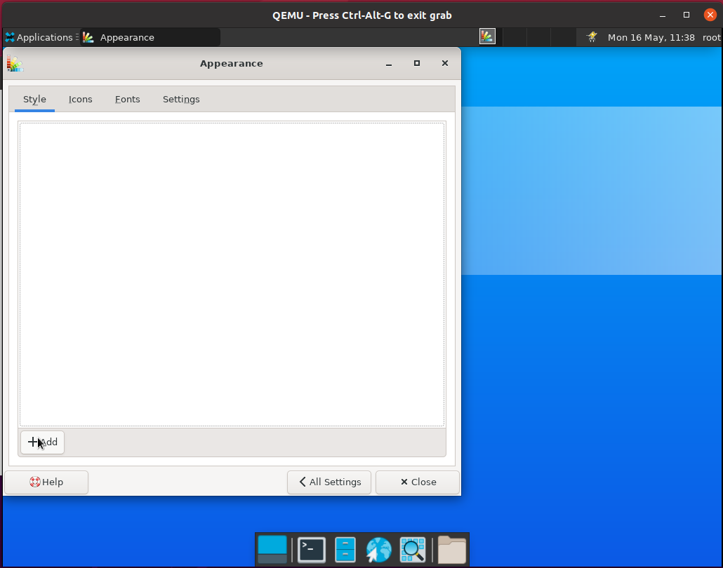

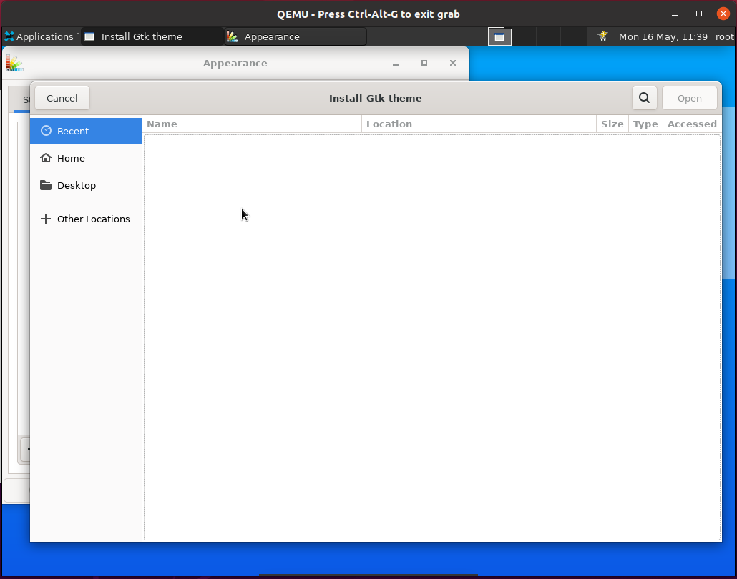进入如下界面

单击“Cancel”回到上级目录单击“Icons”,进入如下界面

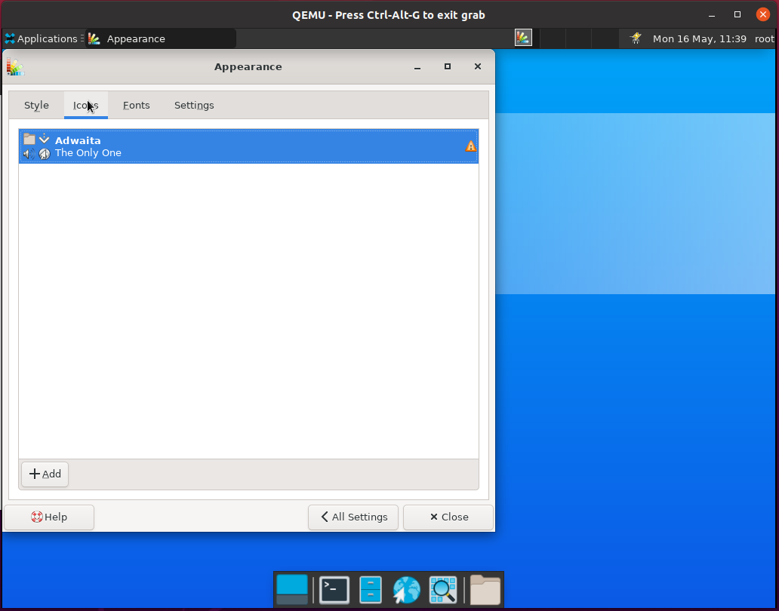

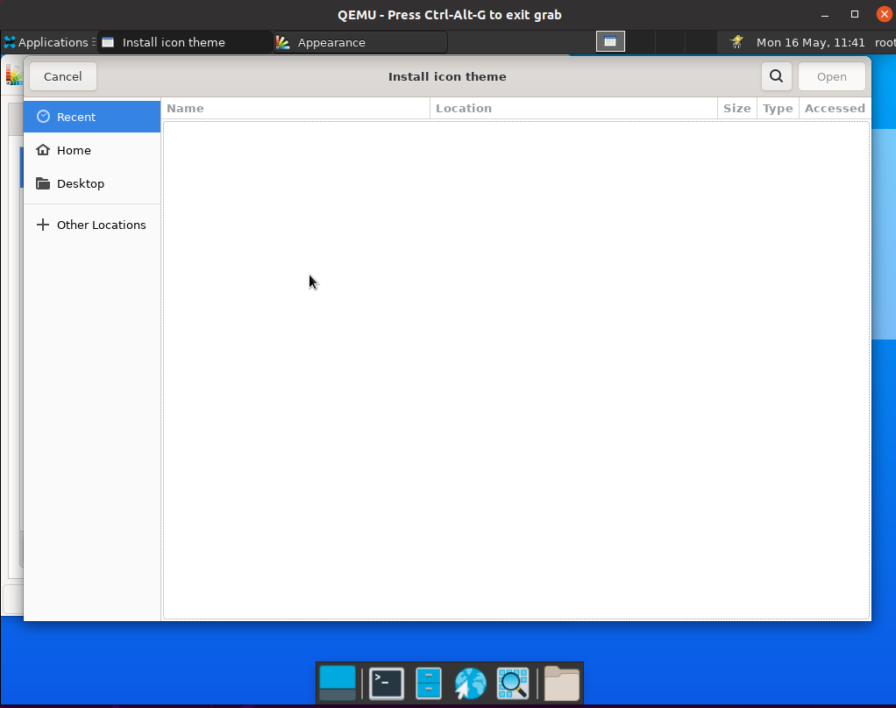单击“Add”进入如下界面

单击“Cancel”返回上级目录单击“Fonts”，进入如下界面

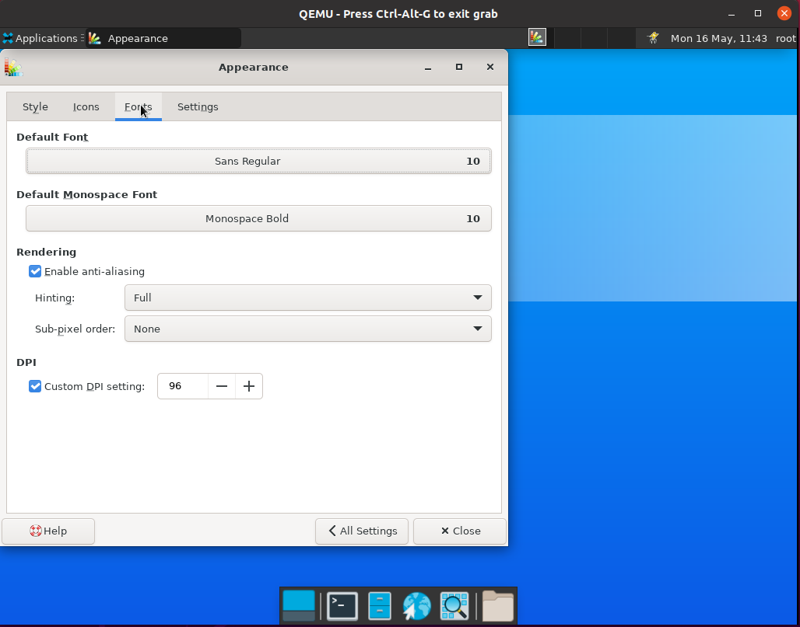

对“Fonts”栏进行测试

Default Font

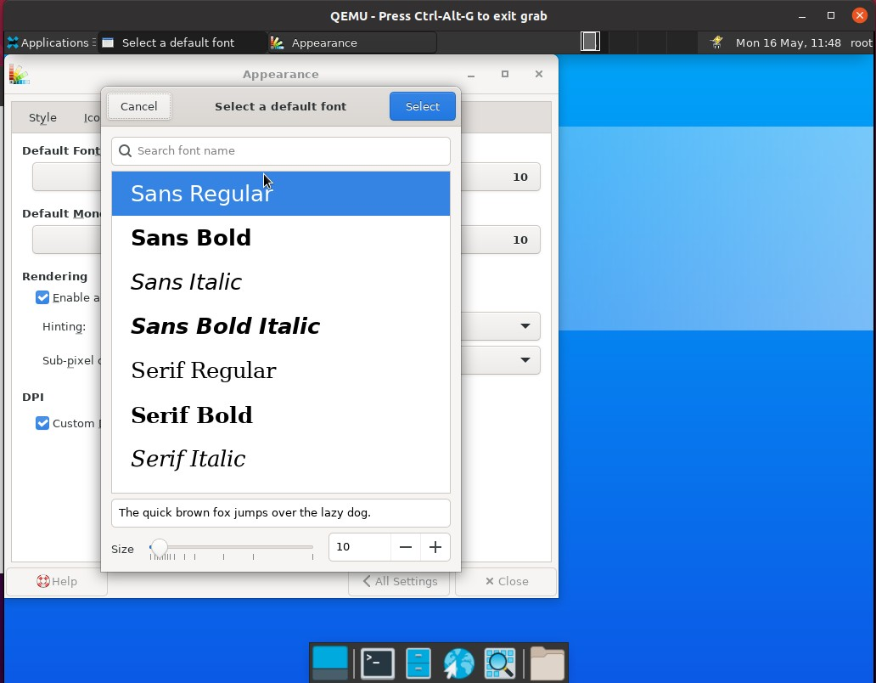

Default Monospace Font

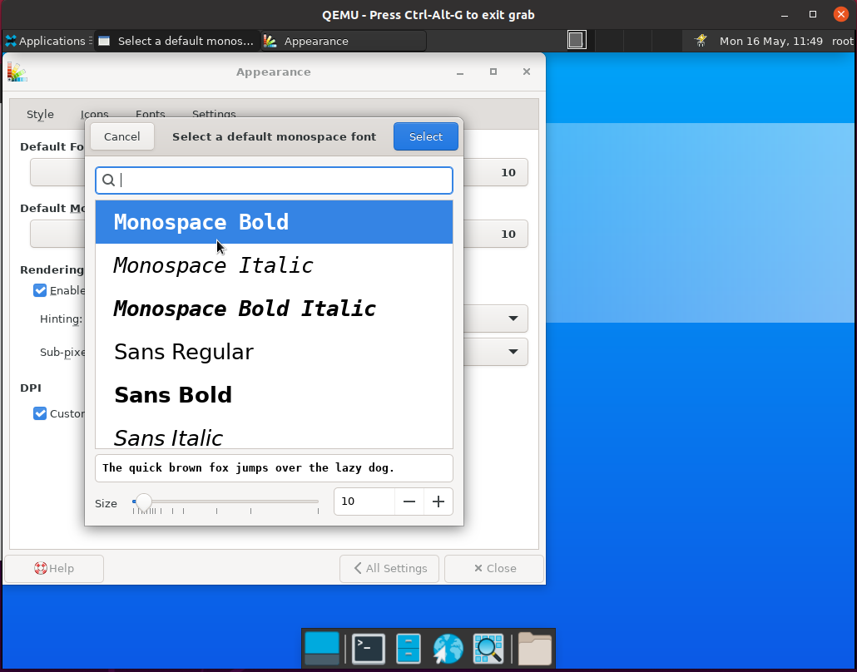

Rendering->Hinting

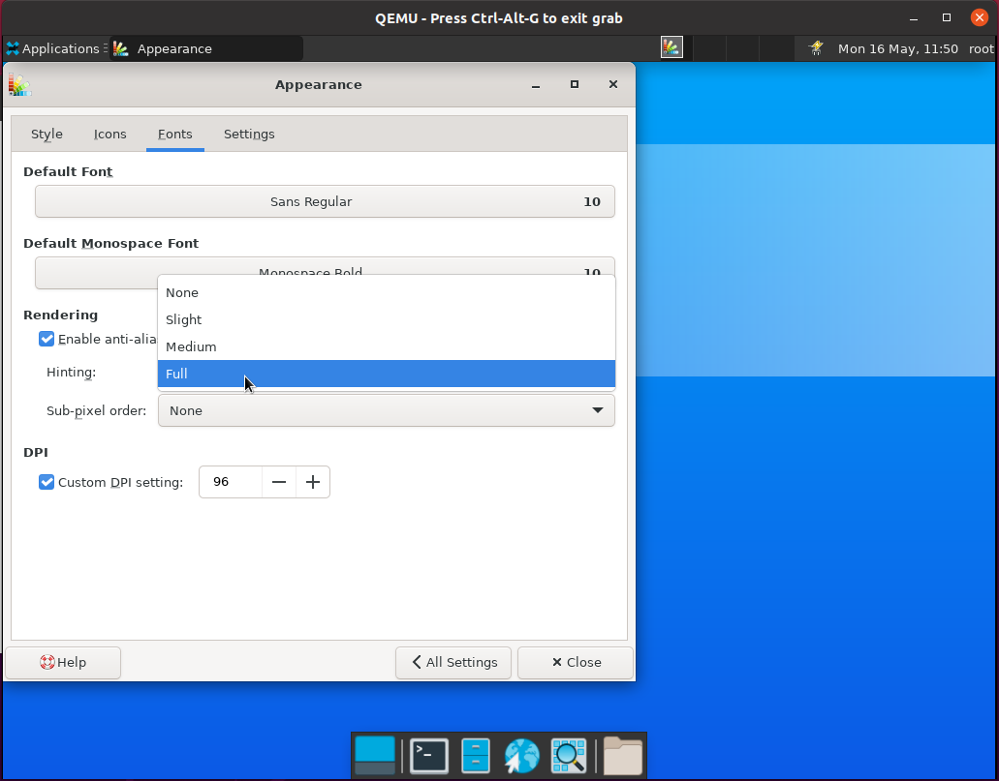

Rendering->Sub-pixel order

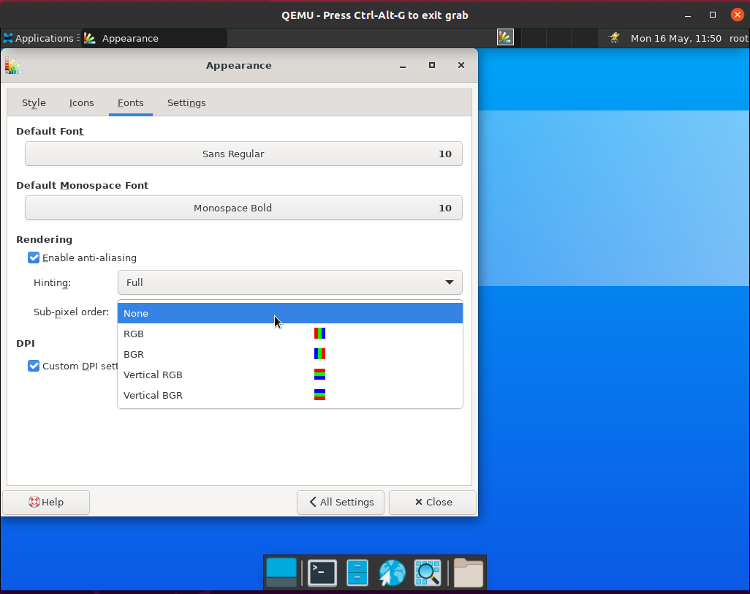

DPI

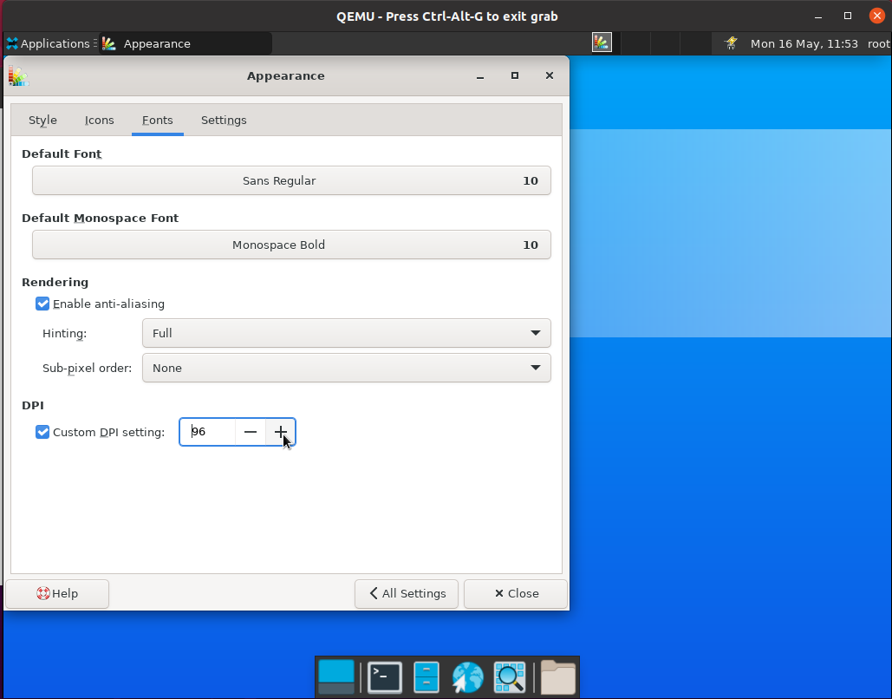

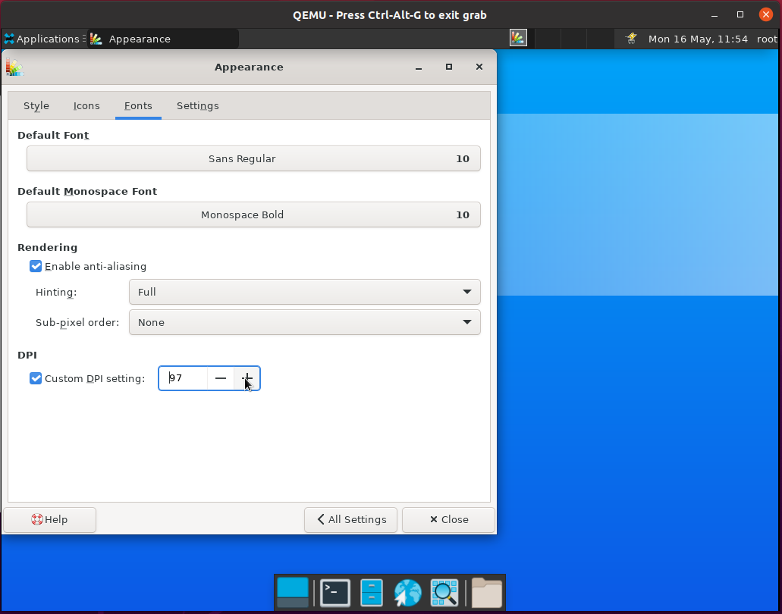

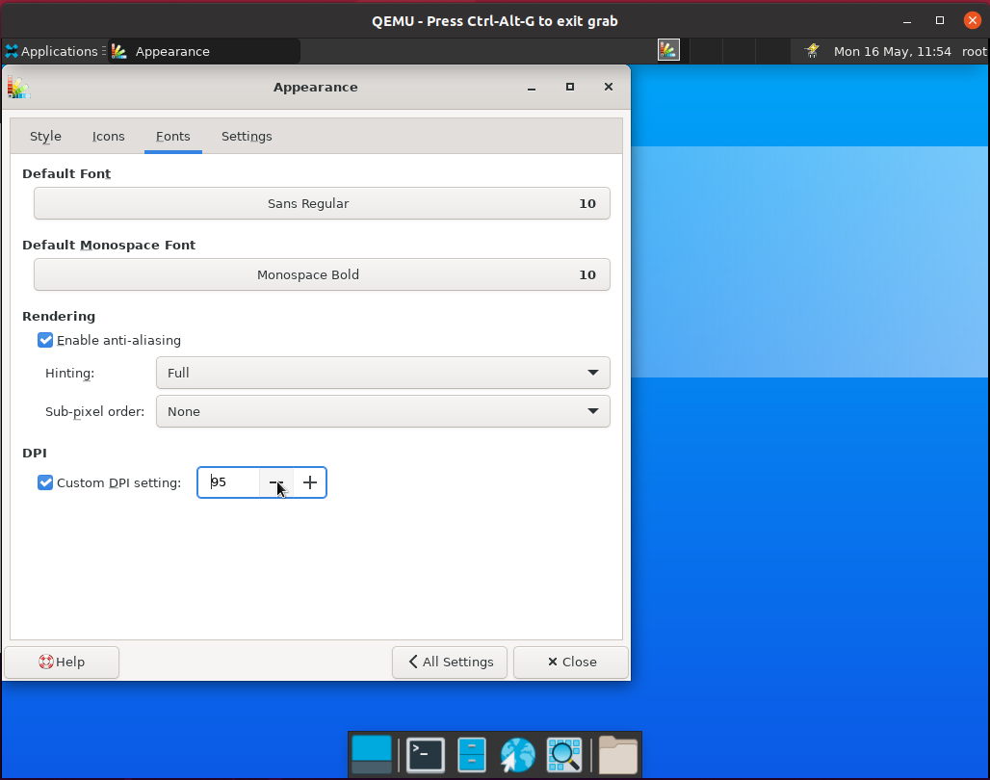

单击“Settings”,对“Settings”栏进行测试

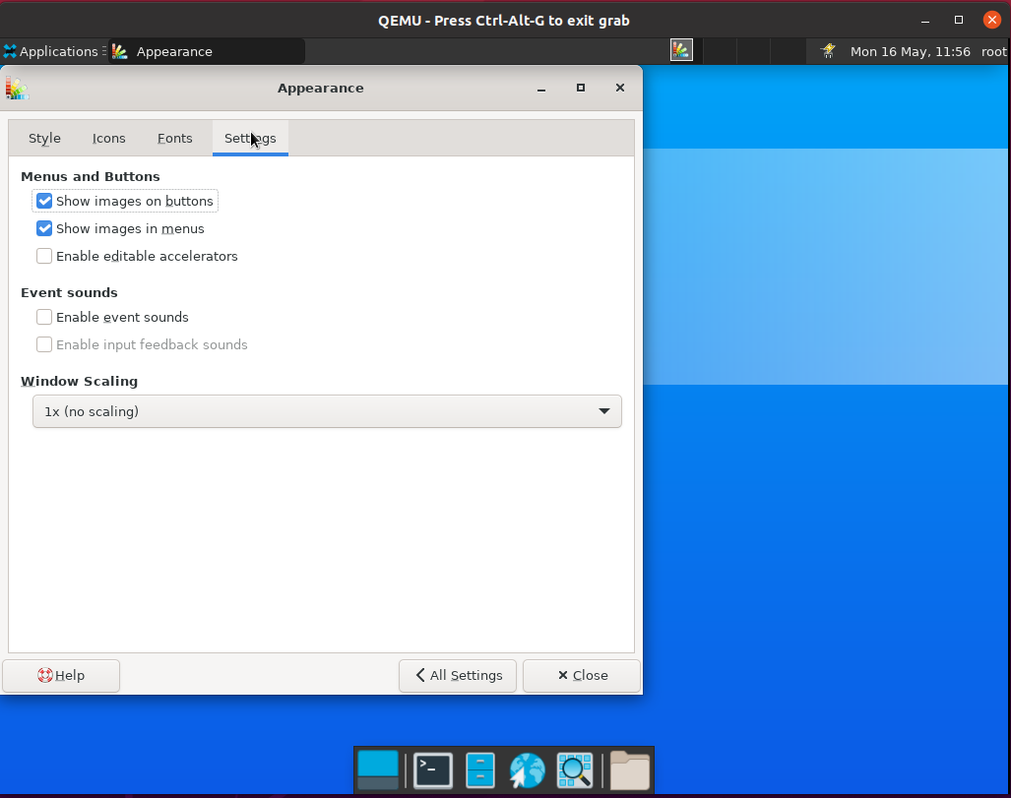

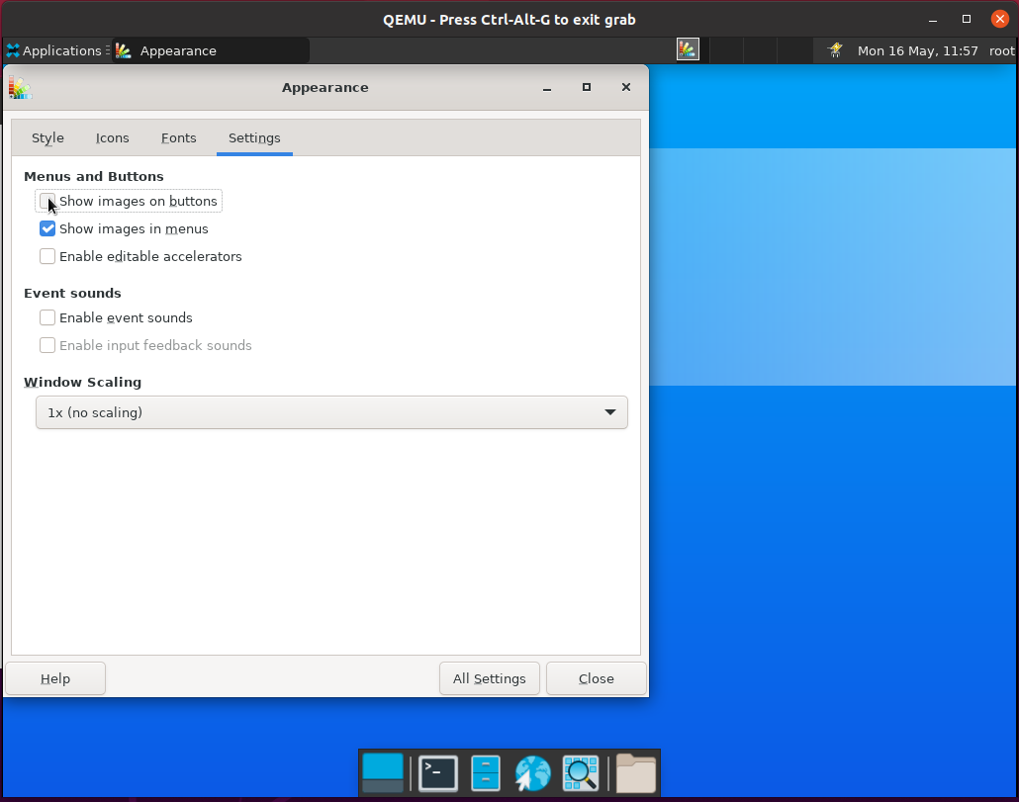测试“Menus and Buttons”

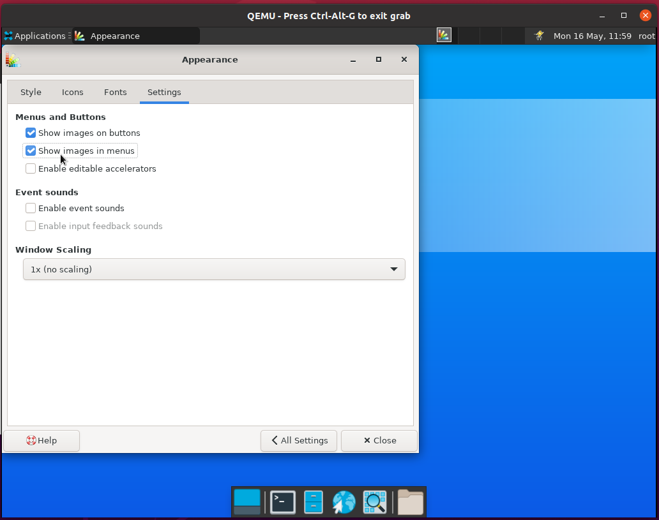

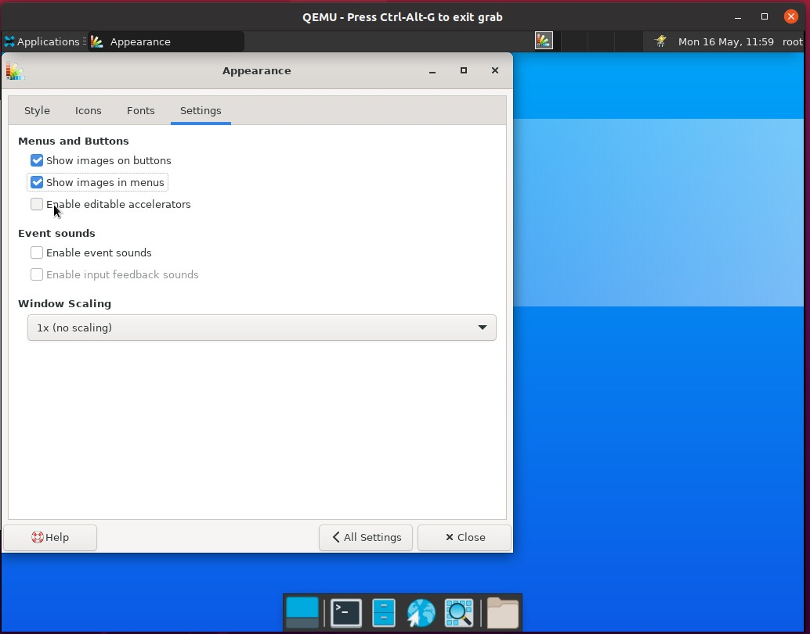

测试“Event sounds”

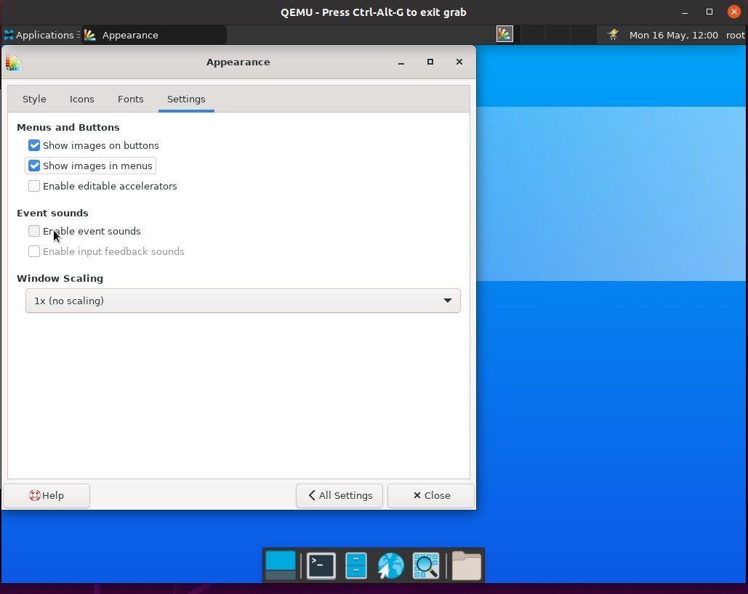

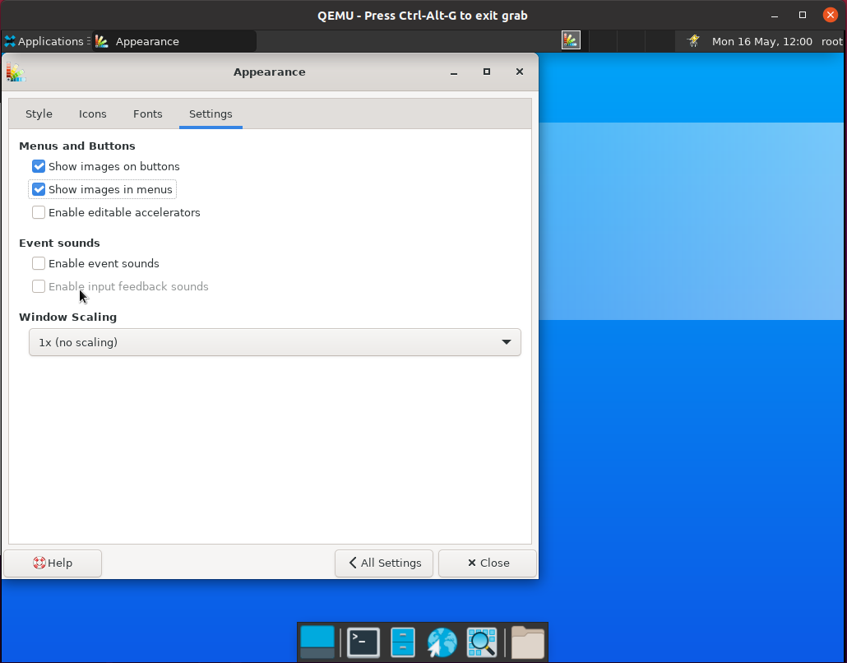

测试“Windows Scaling”

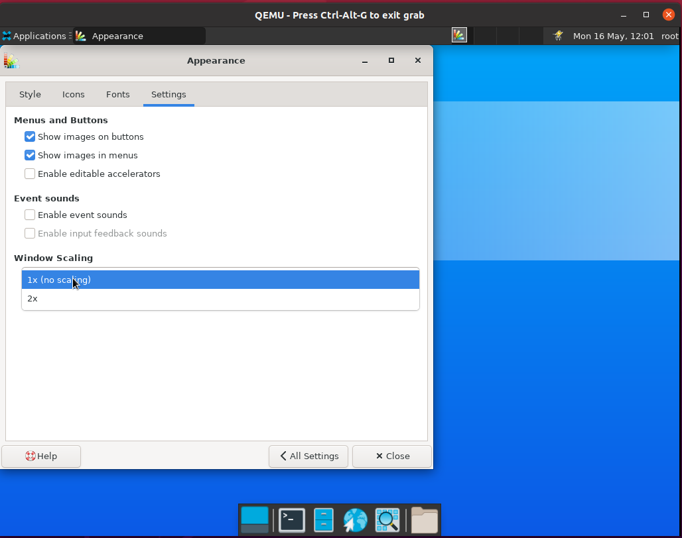

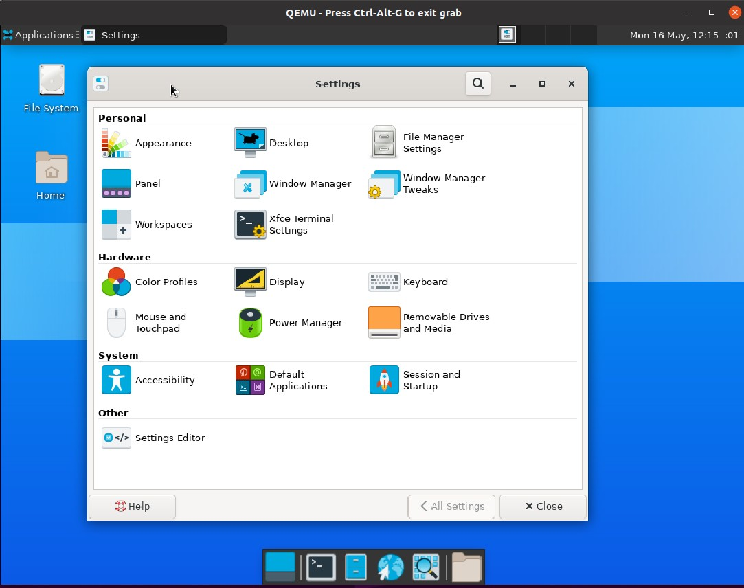点击“All Settings”退出“Appearance”

Appearance功能测试完成

**3 、Desktop功能测试**

### 双击“Desktop”

测试Background栏切换壁纸

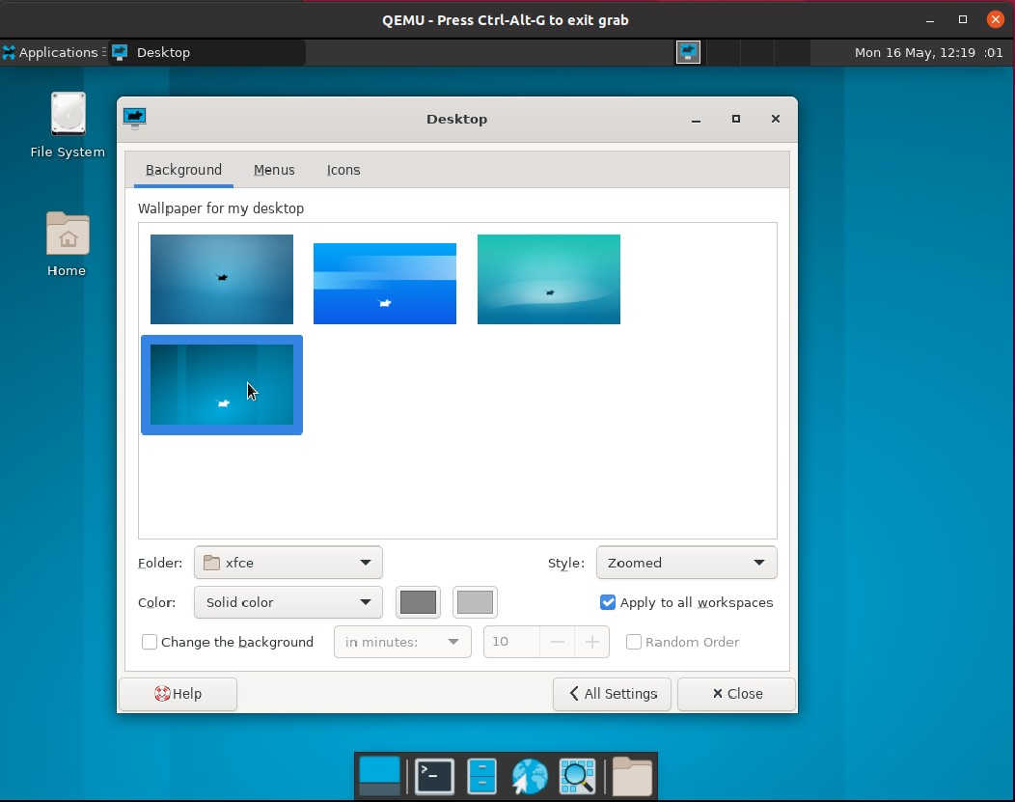

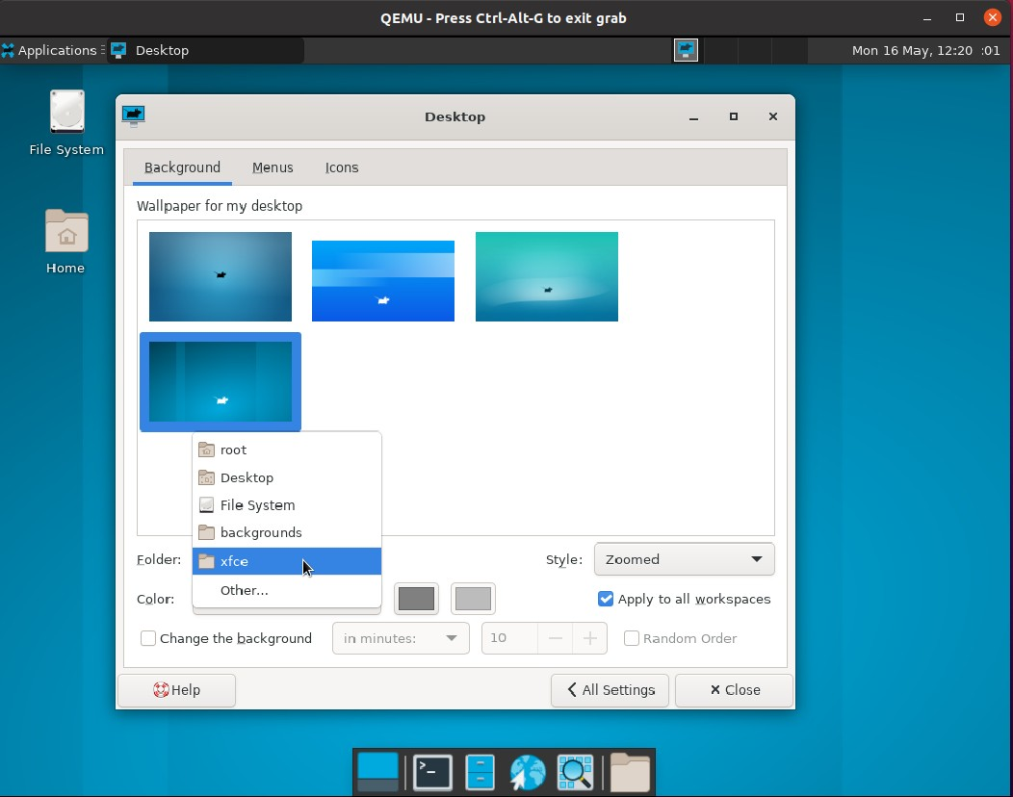测试“Folder”

测试“Style”

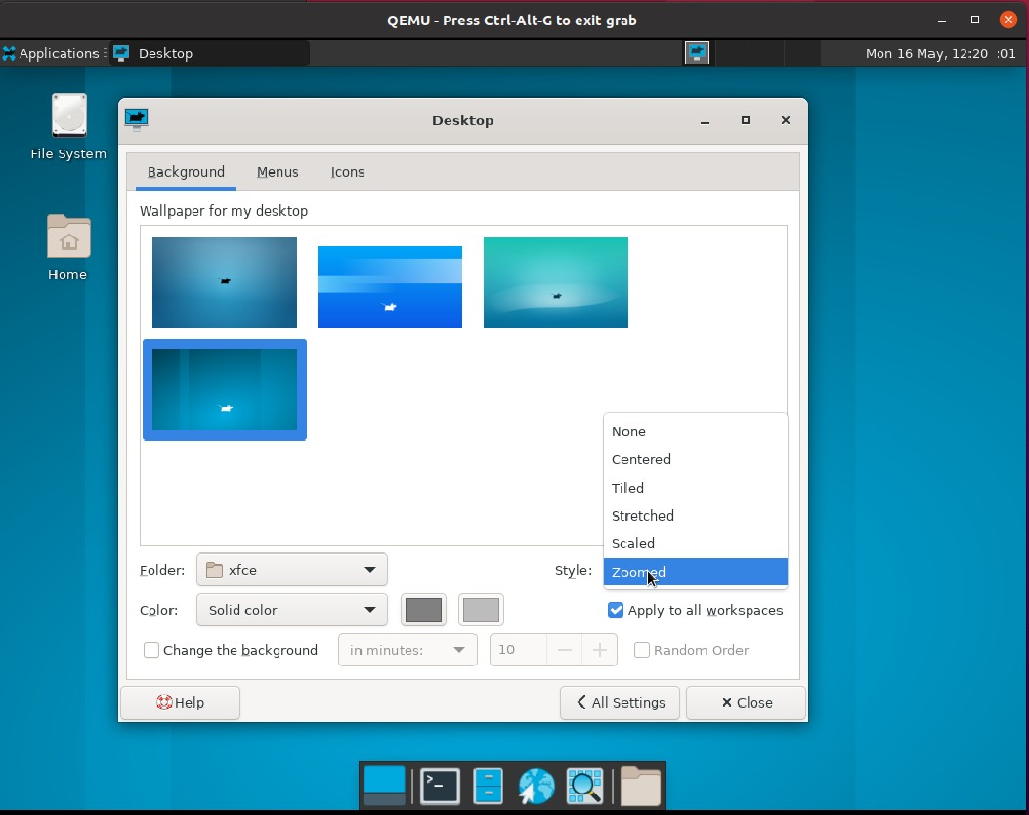

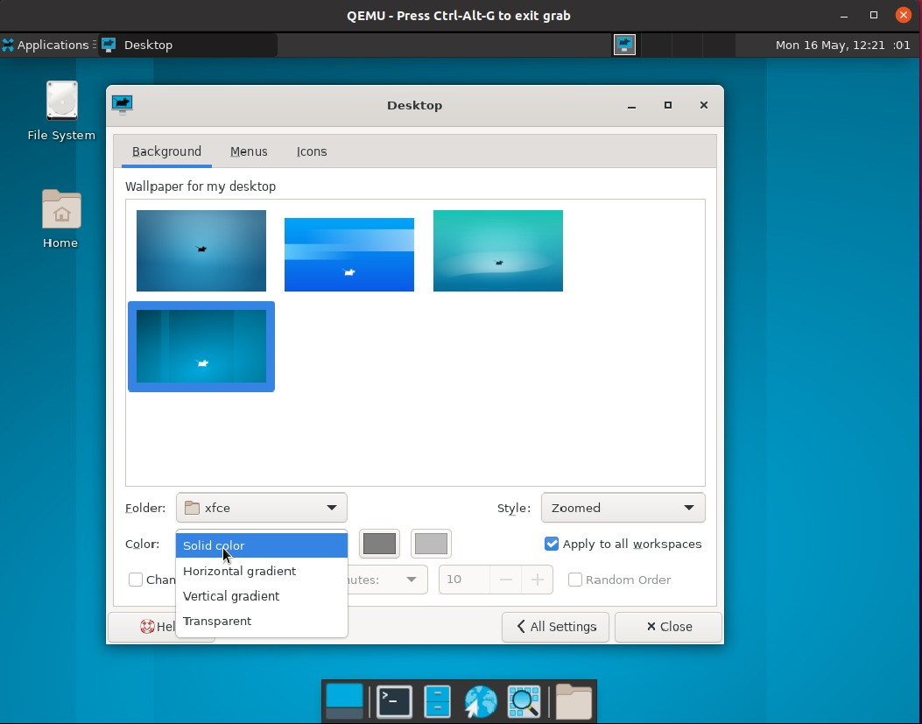测试“Color”

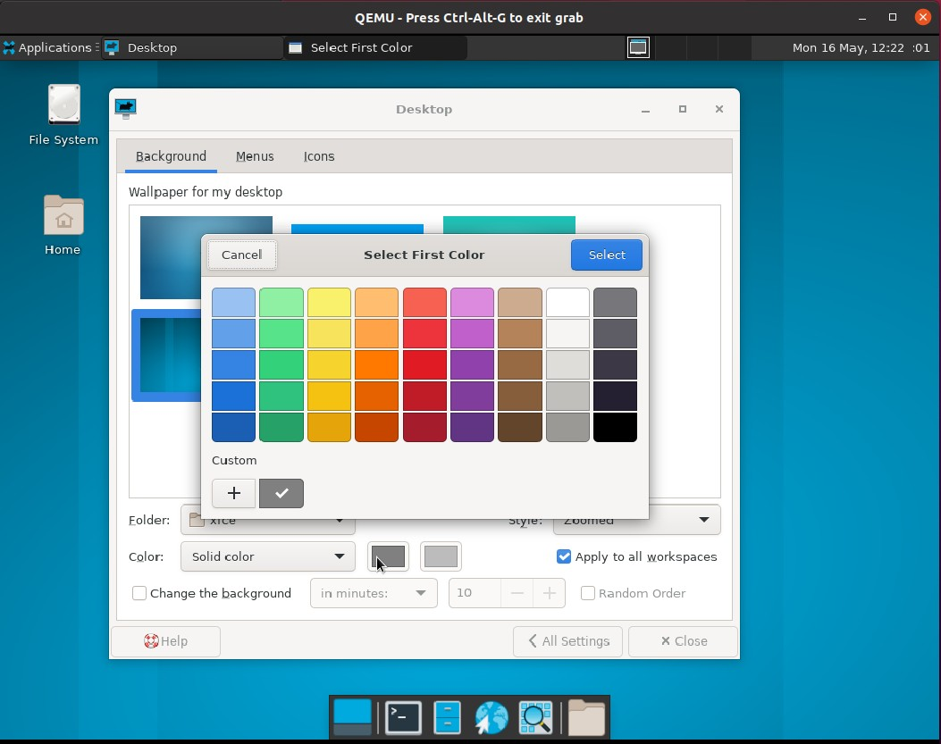

测试“Apply to all workspaces”

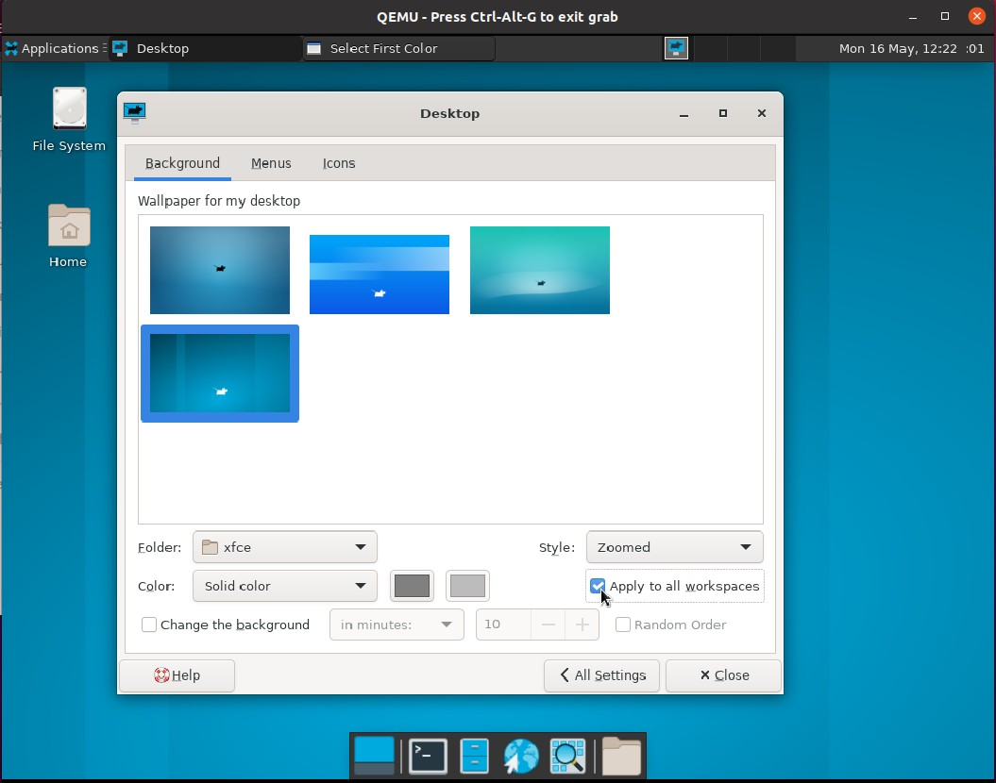

测试“Change the background”

Appli

* Desktop

ons

c at i

□

QEMU - Press Ct rl-Alt- G to exit grab - □ X

##### 

匾 Se l e ct First col or

Mon 16 May, 12,:23

:O 1

Desktoo

口

Backgro und Me n us tcons Wallpape r for my desktop

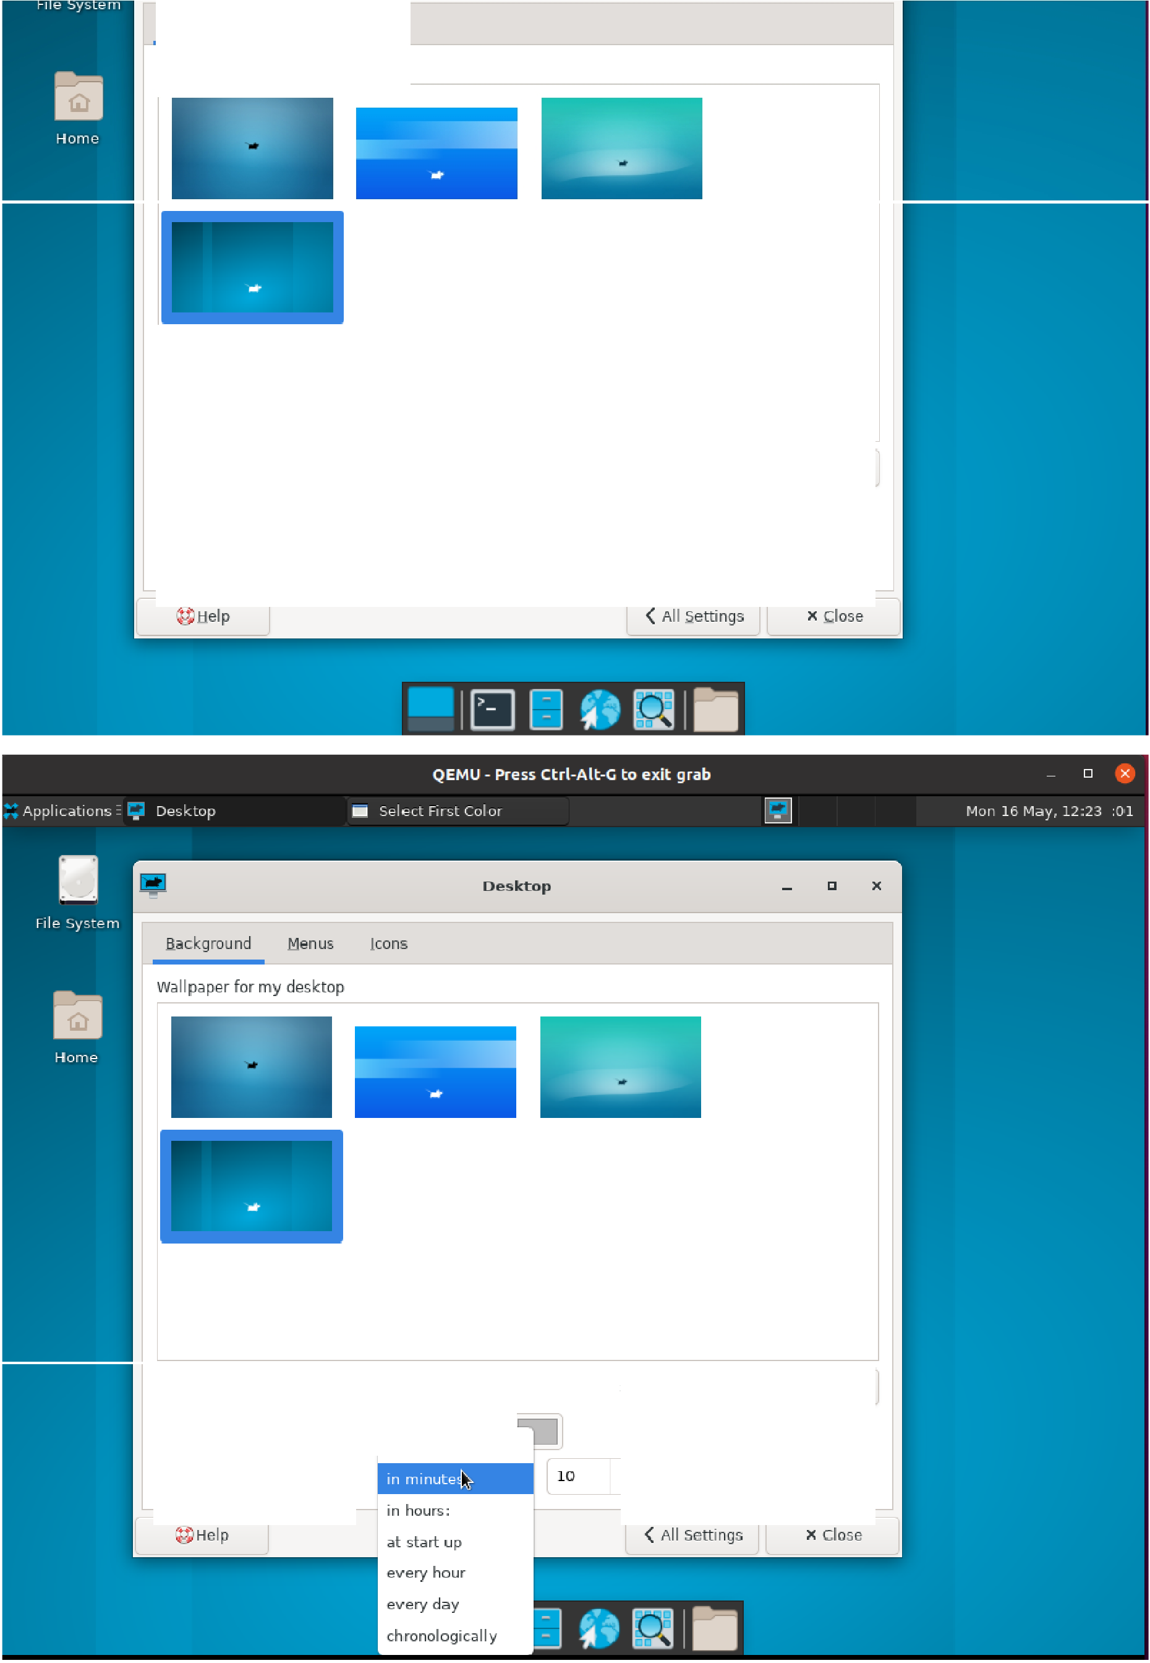

Eolde r: xfce 二

.... l - -

C<>lor: Solid color

只＠a nge the background

##### 乞..., ....,..., ,.

in m inutes: ... 10

5 屯 le : Zoo me d

巴Apply to all 立 orks paces

- + 0 Random Orde 「

[ o lde r. xfce S叨e: Zoo med

CQlor: So li d color

巴Change the hackground

．一 上J.

I in seconds:

巴Apply to a ll 立 orks paces

- + 0 Random Orde r

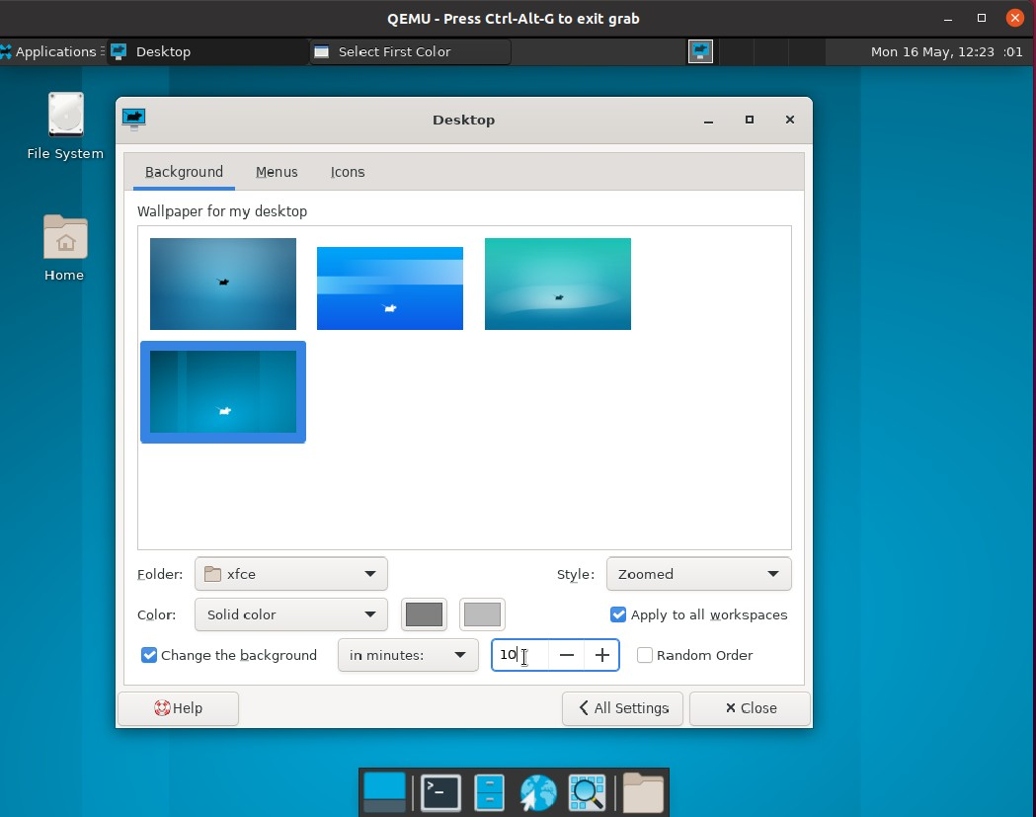

### 测试“Random Order”

测试Menu栏

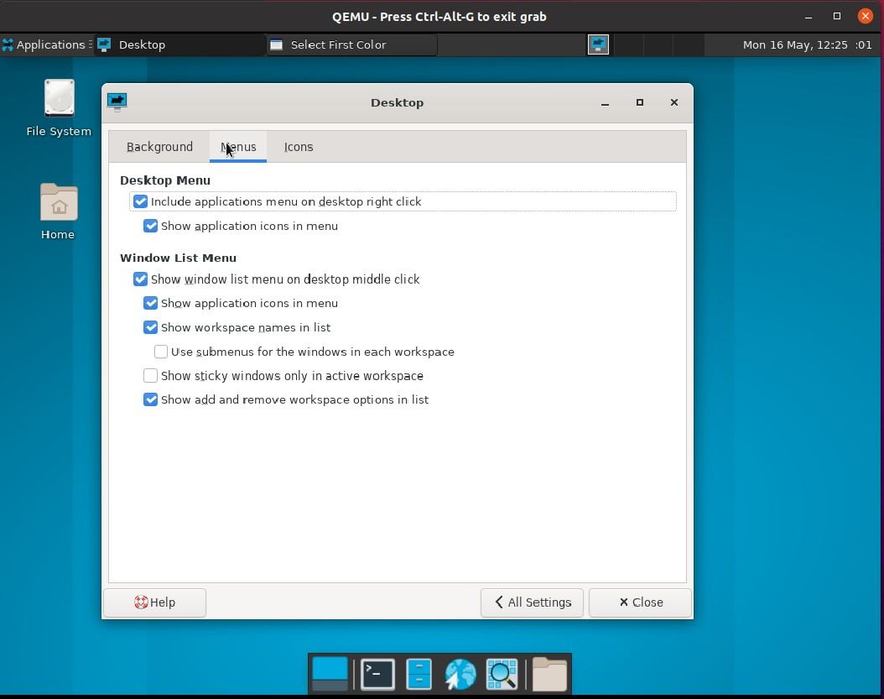

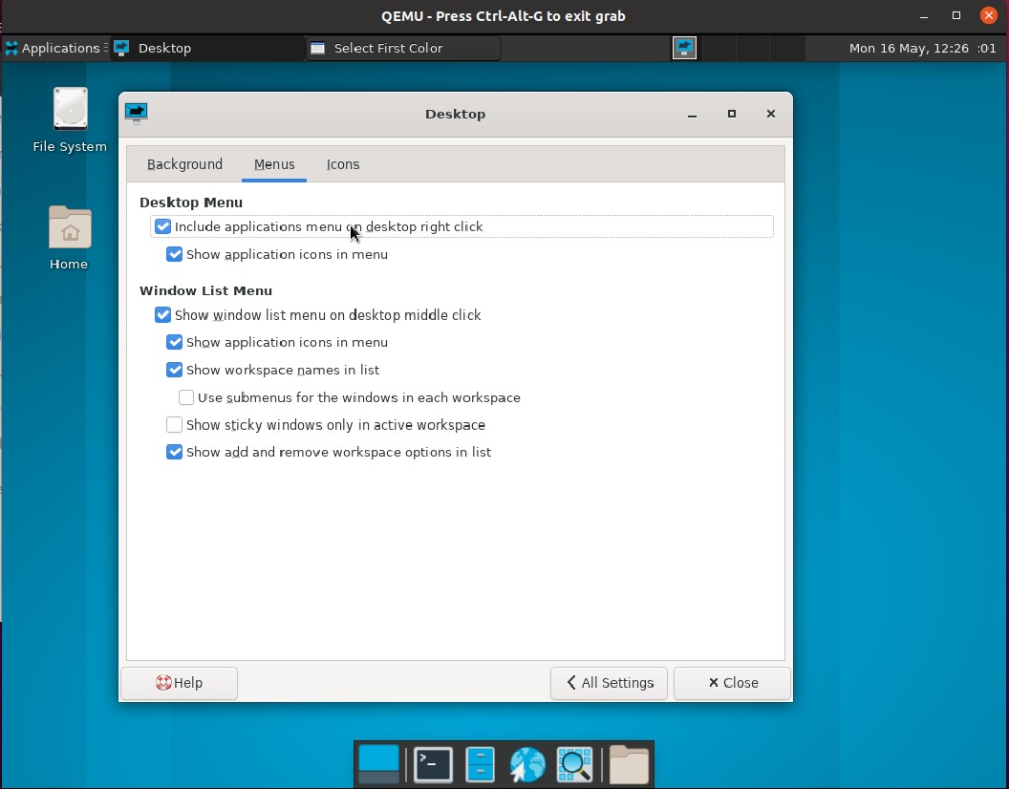测试“Destop Menu”

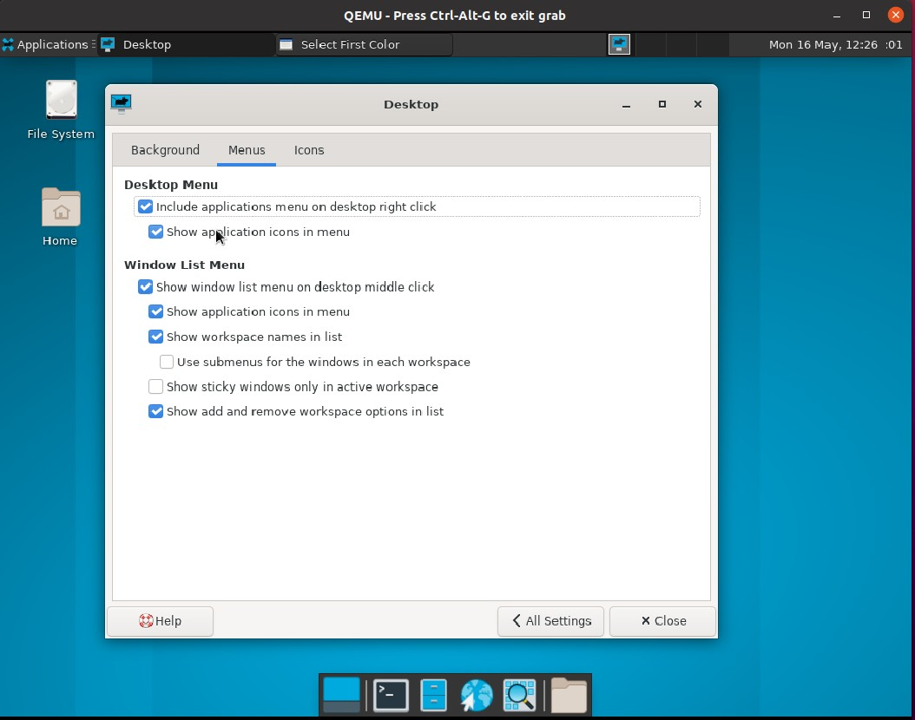

测试“Windows List Menu”

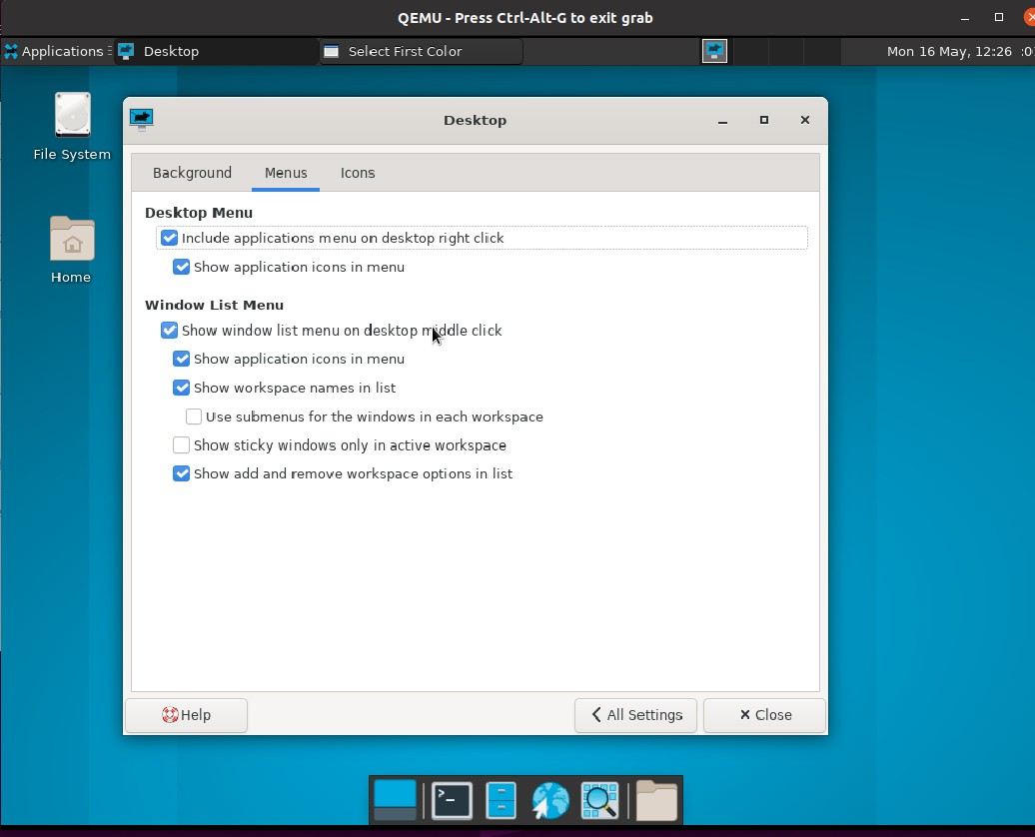

Applications • Desktop

QEMU - Press Ct rl- Alt-G to e xit grab

— Sele ct First Co l or

- □ X

Mon 1 6 May, 12 :27 :O1

De s K 忙 0 们

丿

印 e System

Bac kg「ou nd Men us Icons

Home

Desktop Menu

巴I nclu de applications menu on desktop right click

勹

巳 Show application icons i n men u

Window List Menu

口s how window li st menu on desktop middle click show appli,:at,on,cons in me nu

h-

show workspace names i n list

0 Use submenus for the wi ndows i n each workspace

门Show sticky wi ndow s only in active workspace

巳Show add and remove workspace options in li st

E ] 口介恐 牖

Appl1cations • Desktop

QEMU - Press Ct rl-Alt-G to e xit g「 ab

— Se le ct F， 飞 t Col or

- □ X

巨 Mon 1 6 May, 12:27 :01

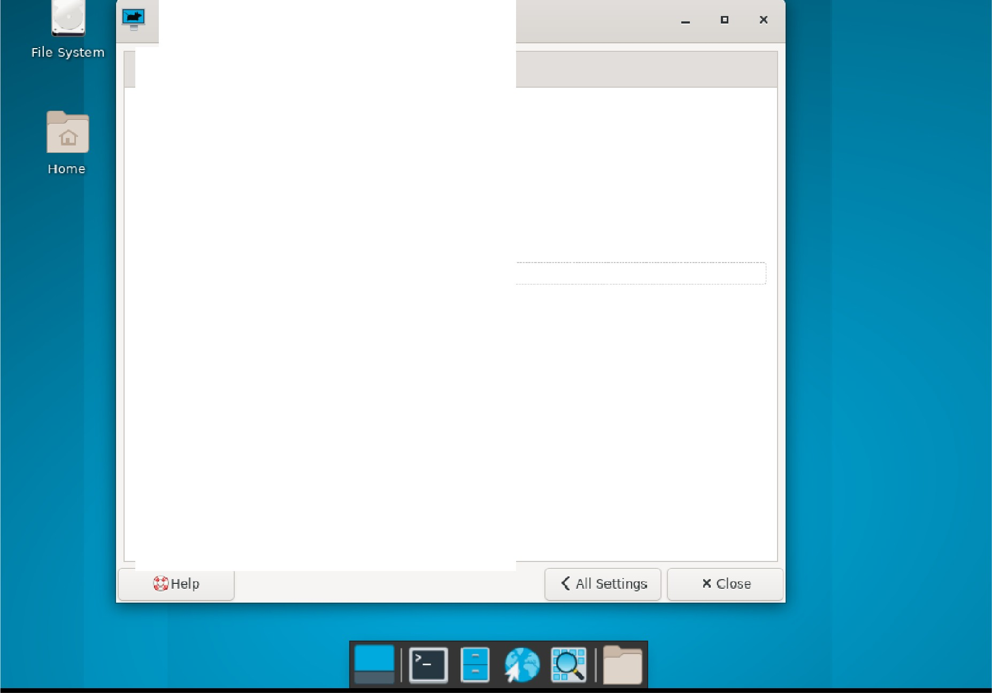

Desktop

Background Me nus

Icons

Desktop Menu

Include applications menu on de sktop right click

巴 s how application,cons m menu

Window List Menu

口Show wi ndow list menu on de s kt op middle click

巴 s how application,cons m menu

巴Show workspace nam"h.s in list

0 Use su bmen us for the 广 windows in each workspace

勹 Show sticky windows only in active workspace

巴 Show add and remove workspac.e opti ans i n list

Applications. Desktop

□

#### 

QEMU- P

「ess Ct「

画 Sel e ct First col or

- □ X

巨 Mon 16 May, 12: 27 :Ol

l-Alt- G to exit grab

Deskta

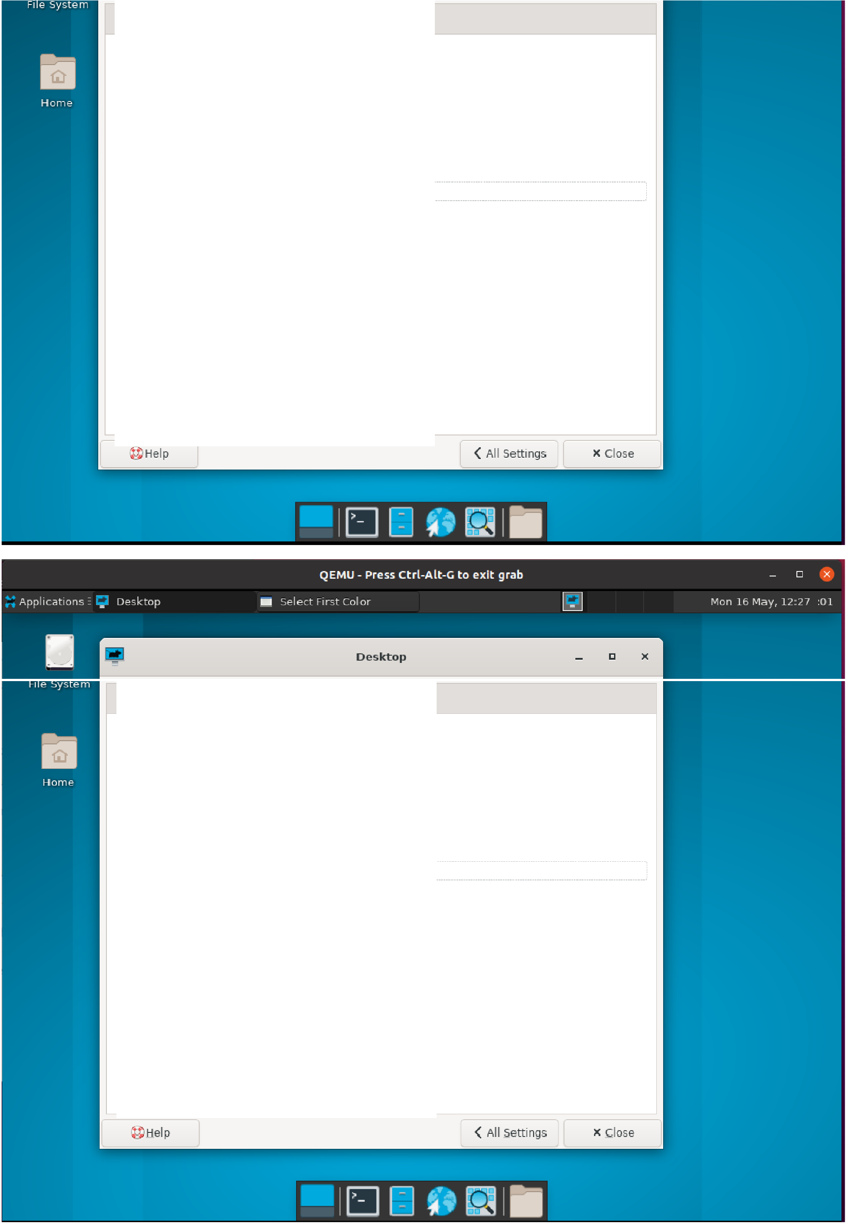Background Menus Icons

Desktop Menu

f';j I nclude applications men u on de sktop right d ick

f';j show application,cons in me n u

Window List Menu

口Shov, window lrst men u on de sktop midd le click

巳 Show applicat ion icons rn me n u

巳 Show workspa _:e na mes in lrst

[l Use sub r e nu s fo 「 t he windows in each workspace

门 s how sticky windows only in a过ive wo 扣 pace

f';j show add and remove workspace options i n li st

Background Menus Icons Desktop Menu

已I nclude applications menu on de sk top right click

f'.l Show application,cons in menu

Window List Menu

口s how window list me nu on de sktop midd le dick

巴shnw application,cons in menu

r;i show workspace names in lis t

□Use s ubmen us for the wind ows in each workspace

□s how sticky windc 岱s only i n act ive wo「 kspa ce

巴 s how add and remove works pace options i n list

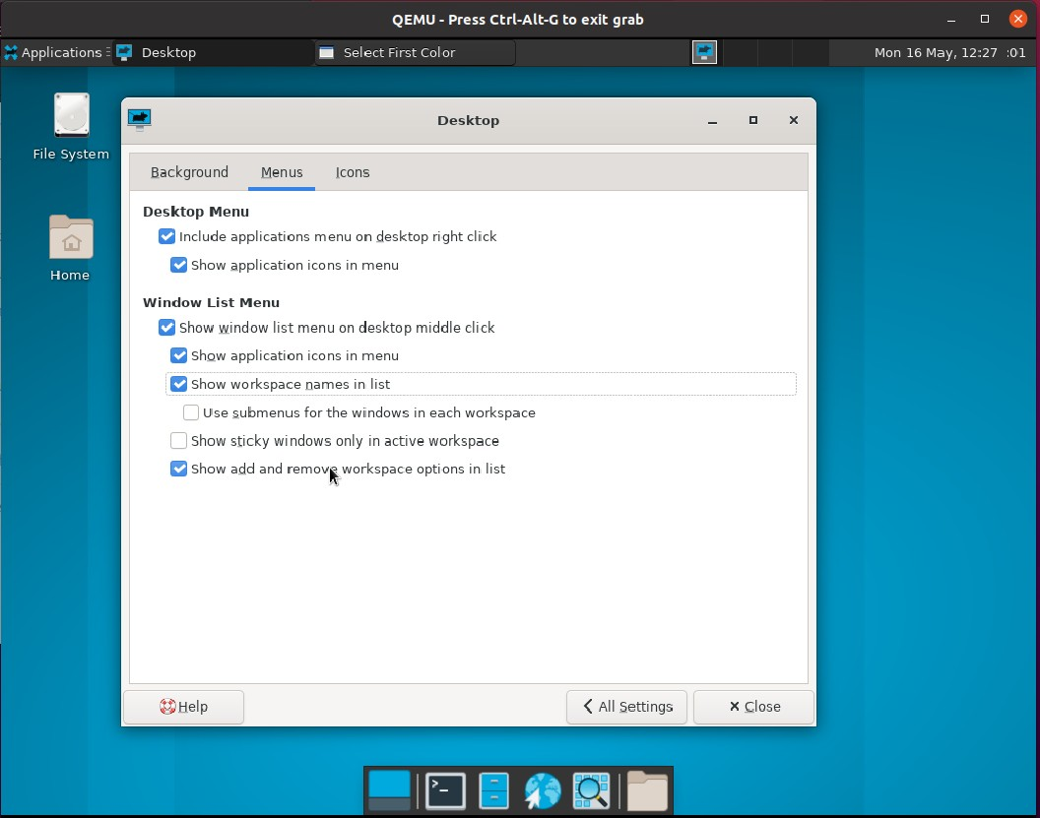

### 测试Icons栏

测试“Appearance”

Desktop

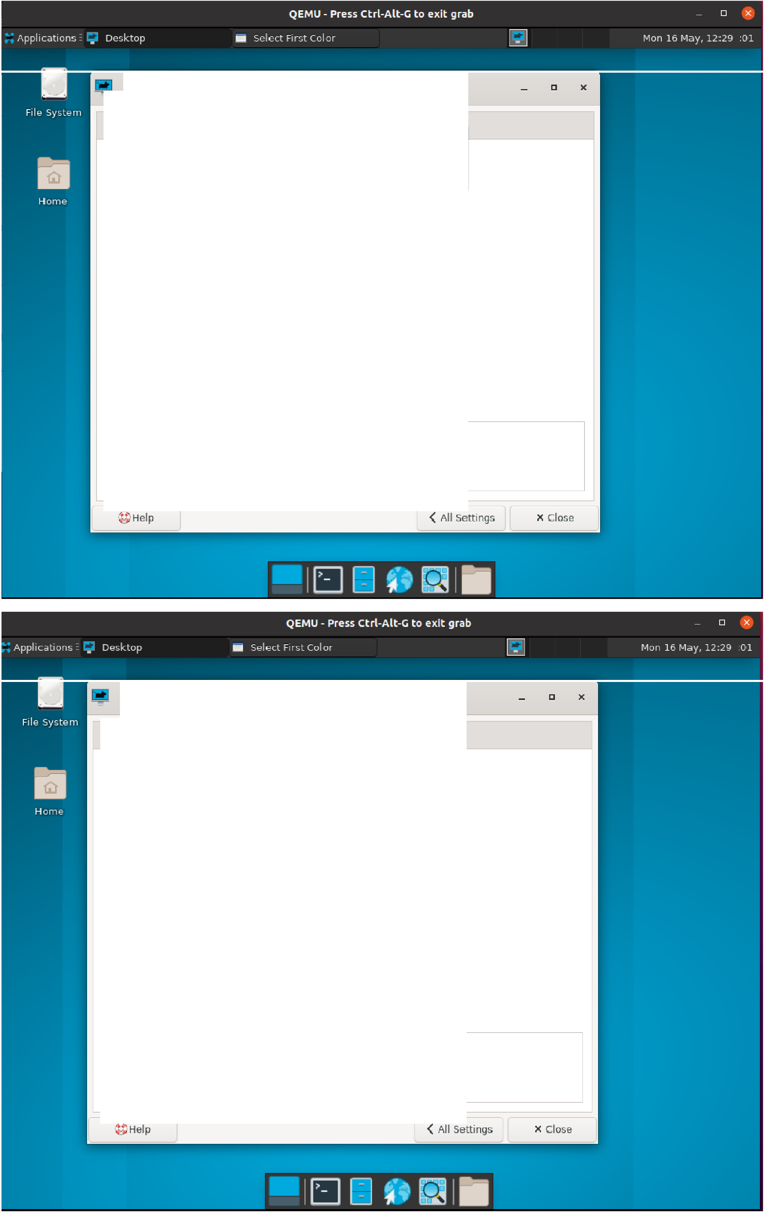

~~＿~~

Background Men us Icons

Appe a ra nce Icon type:

民

None

Minimize d applic at ion ic ons

Ic on 12e :

48 - +

Ic ons .une nt ,at o n: Top Left Vertical

0 Show icosn

on primary dis pla y

LJ Use cus t om font stze:

r',I show ic on t oo lt i ps. Size:

巳Show th u mbnails

厂Show h idde n files on the desktop Sing le 仁 li ck to activate ite ms

12

1 28 - +

Default Icons

0 氐 Home

口 D File System

口百 Tras h

, 0 巴 Re movab le Devices

DesktOJ)

Bac kgro und Menus Icons

Appearance

Ic o n type: File/launcher,cons ... l

|  |  |  |  |
| --- | --- | --- | --- |
| Icon ize :  lc o ns 1Jne nt at1on: | 曰－ ＋ I  Top Left Vertical | | ] |
| 0 show icons on prim ary dis pla y |  |  |  |
| 0 Use c ust om font size: | 12 |  |  |
| 巳show icon too lt ips. , s ze : | 128 | - + |  |
| 巳 s how thu mbnails |  |  |  |
| 二Show hidden files on the desktop  0 Single d ick to act ivate items |  |  |  |

Default Icons

Ha rne

巴巴 File System

口百 Tras h

, 0 巴 Re movab le Devices

Applications. Desktop

□

QEMU - Press Ctrl-Alt-G to exit grab

* select First col or

— 口 X

二］ Mon 1 6 May, 12:29 :O l

[)es Kco 们

监＇缢

Appearance

勹

Men us Icons

# ＿

Home

Ic on type · Fil e/ la uncher icons

Ic on •ze: 48 一 十

Ic ons ll『1e nt at1on.

己s how icons on primary dis pla y

口 Us e cust om font size:

rJ Show icon too ltips. Size .

rJ show tbum bnails

0 show hidde n files on the desktop

0 Si ng I e dick to activate ite ms

Top Left Ho rizon`t al

Top Right Vertic al

Top Right Horizonta l Bottom Left Ve rtical Bottom Left Horizont al Bottom Ri ght Vertica l Bottom Right Horizo nta l

Default Ic o ns

口 Home

乙 D File System

口百 Tras h

* + 乙 l!!I Removable Devices

E]口.

$. I■

Applications • Desktop

QEMU - Press Ctrl-Alt-G to exit grab

画 Sele ct First Col or

- □ X

口 Mon 1 6 May, 12"29 :01

[)o

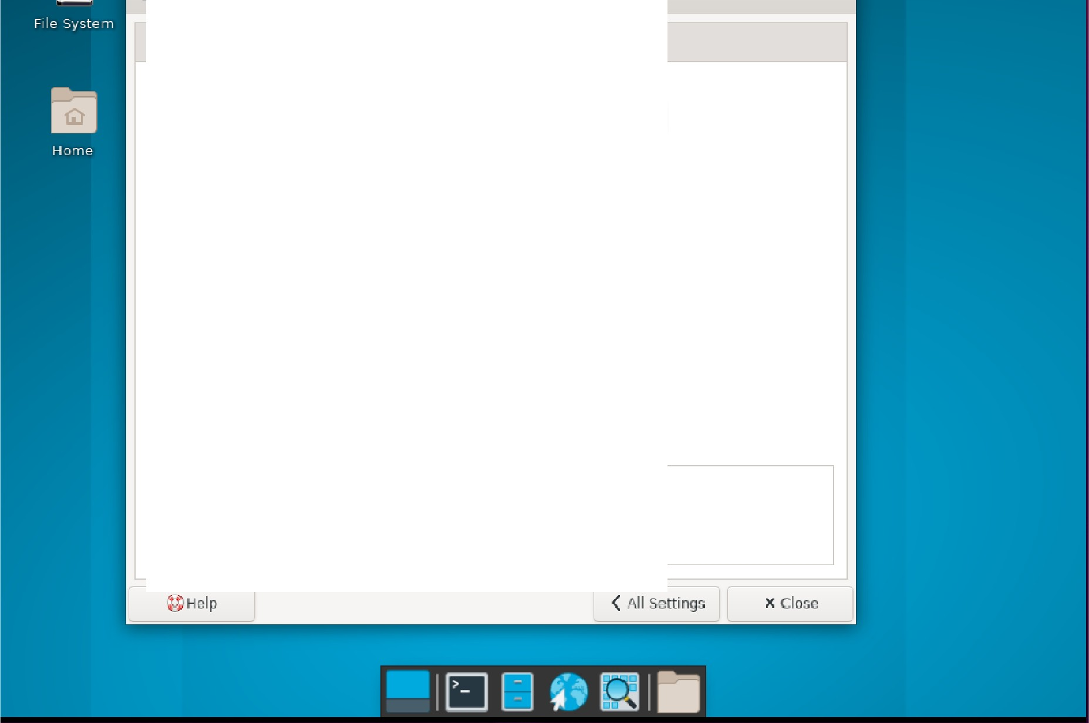

Background

Menus

Icons

Appearance

Icon type ·

File /launcher ,cons

... l

Icon s oze· 48 - +

Icons orie nt ation:

0 Show icons on prilJlary dis pla y Use cus t om fo t s e: ' ,

Top Left Vertical

... ，'

，

12

rJ show icon tooltips. Size : 1 28 - +

rJ Show thumb n叫s

仁］Show hidde n files on the desktop

口Si ngle dick to act ivate items

Default Ico ns

口玉 Ho me

巴 D 印 e System

口百 Tras h

* 巴巴 Re movable Devices

QEMU - Press Ct rl-Alt- G to e xit grab

A＿pplications.

画

Desktop

se l e ct Fi rot col or

□

— 口 X

巨

Mon 1 6 May, 12:30 :Ol

[)eskt:oo

且ac kground Me nus Icons

Appe a ra nce

Ico n type Fil e/ la unche r ,cons ]

勹

Home Ico n ize :

Ico ns Qne nt at ,on:

0 show icons on primary display

0 Use custom fo t size

##### 良

l!'J show icon tooltips. Size: Show 山 u mbna il s

0 Show hidden files on the desktop

0 Si ng l e dick to activate items

Default Icons

巴巨｝日ome

乙口白le System

口百 Tras h

* 已 !!!I Re movab le De vices

立 t1eIP

48 一 十

Top Left Ve巾ca l ］

12

1 28 - +

厄］巳．＄． 岔 牖

App lic ations . Desktop

QEMU - Press Ctrl-Alt-G to e•

画 sele ct First col or 巨

lt grab

- □ X

Mon 1 6 May, 12 :

:30 :Ol

[)e sk rn 口

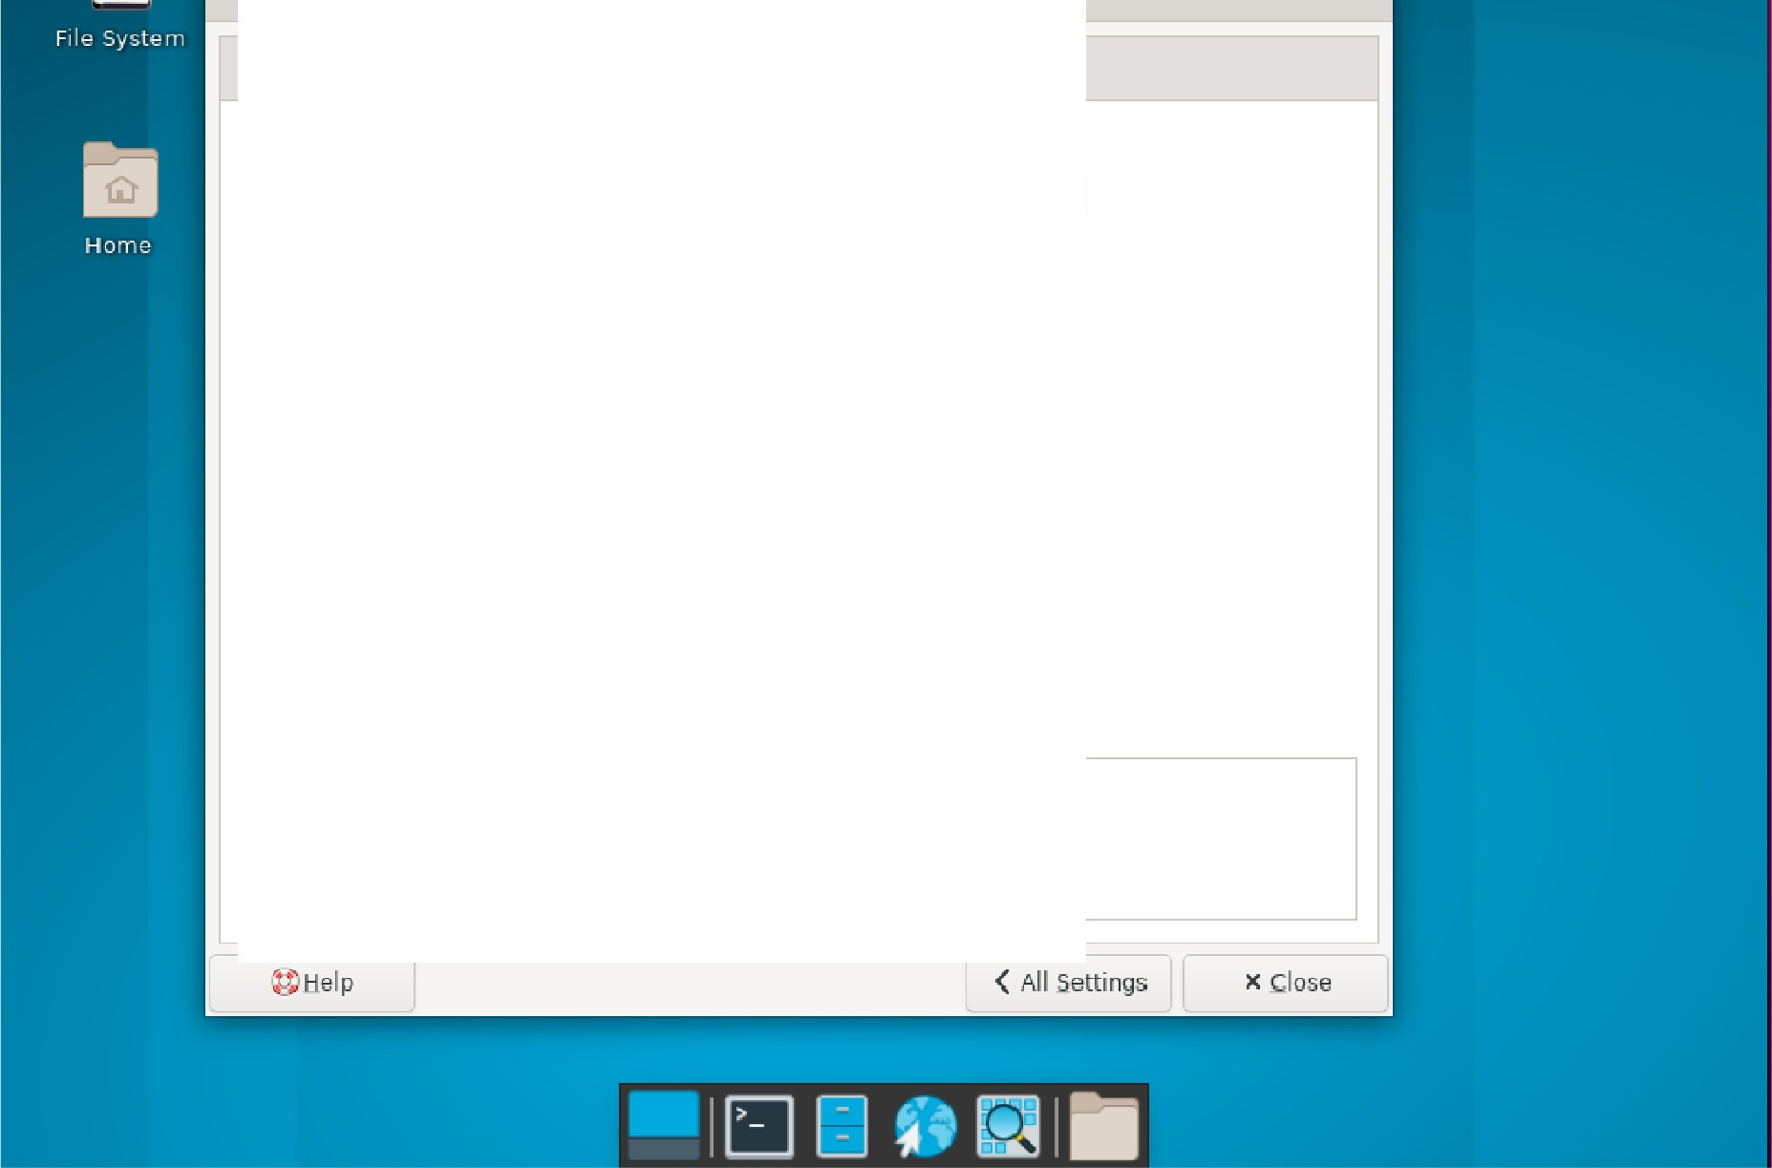

B.ackgrou nd Menus Jeans

Appe a ra nce Icon type ·

File /launcher ,cons

... ]

Icon 五12e: 48 - +

Icons one nt atio n,

□s how icons on primary dis pla y

0 Use custom font size:

r'J Show icon too ltips. S12e ·

r'J Show tbumb n圳s

0 Show hidden files on the desktop

0 Single d ick to activate items

Default Ico ns

口 riij Ho me

巴 0 问 e System

口百 Tras h

* 巴巴 Removable Devices

Top Left Vertical

..... l

12

巳二

Applications •

Desktop

□

＿

|  |  |  |
| --- | --- | --- |
| QEMU- P「 | e ss Ct「 | l-Alt-G t o exit grab |

圈I Sel 1

- □ X

Mon 16 May, 1 2:30 0 1

DesK CO 们

口

|  |  |  |
| --- | --- | --- |
| e ct F | 飞 | t Col or |
|  |

Background Menus Icons

Appearance

Icon type . File/launcher,cons

勹

Hom e Icon s ize. 48 - +

Icons onentat,on.

0 show icons on primary dis pla y

0 Use c ust om font s12e· show icon too lt ips. s, ze:

巳 Show thu mbo, a ls

片广

0 Show hidde n 付 es on the de sktop

□Si ng I e click to act ivate items

Default Icons

口固 Hom e

D File system

口百 Tras h

* 巴巴 Re movab le Dev ic es

O H Rl o

Top Left Ve巾ca l

12

128 - +

Applications. Desktop

iii select First col or

— 口 X

二］ Mon 1 6 May, 12:30 :O l

巳巳＄曹＂ 员1

grab

QEMU - Press Ct rl-Alt -G to exit

.

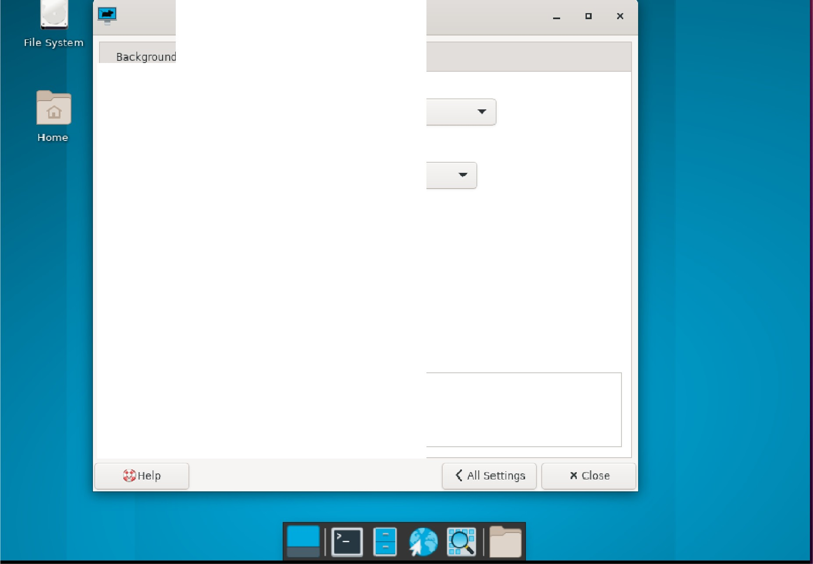

Desktop

Menus

Ic ons

Appearance

Ico n type

File/ la un c her ,cons

Ic on si ze:

48 一 十

Icons one nt at,o n:

0 Show icons on prima ry dis pla y

Top Left Ve巾cal

0

Use c us t om font size:

「 1 2

s how icon too ltip s. Size · 1 28 - +

Show thu mbnails

0 Show hidden files on t e desktop I 口 , s ng Ie click to activat\ te ms

Default Ico ns

巳 Ha rne

0 File Syste m

口百 Tras h

* 巴巴 Re movab le Devices

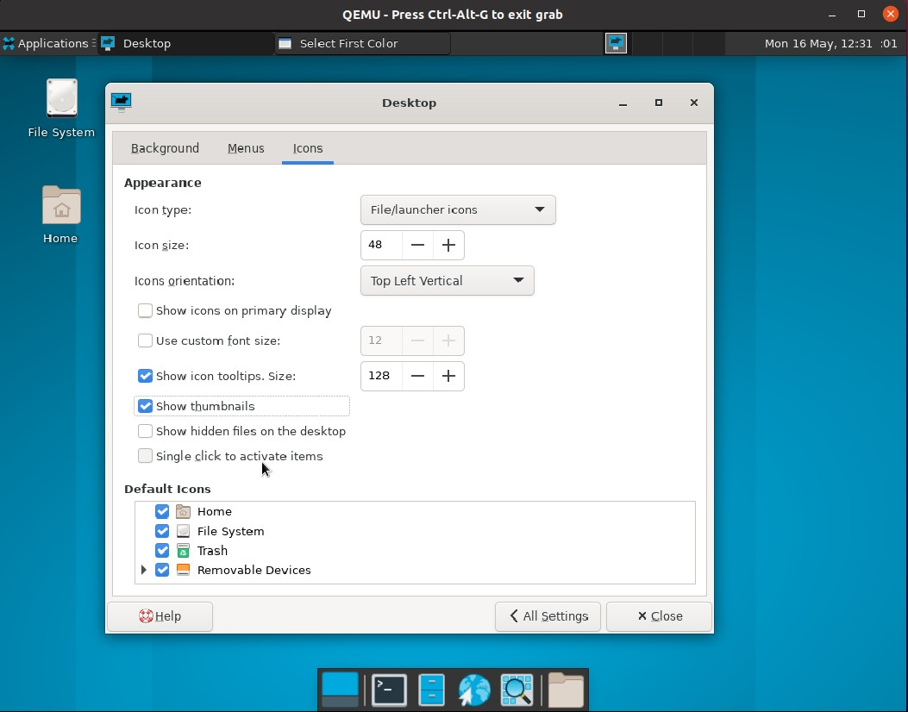

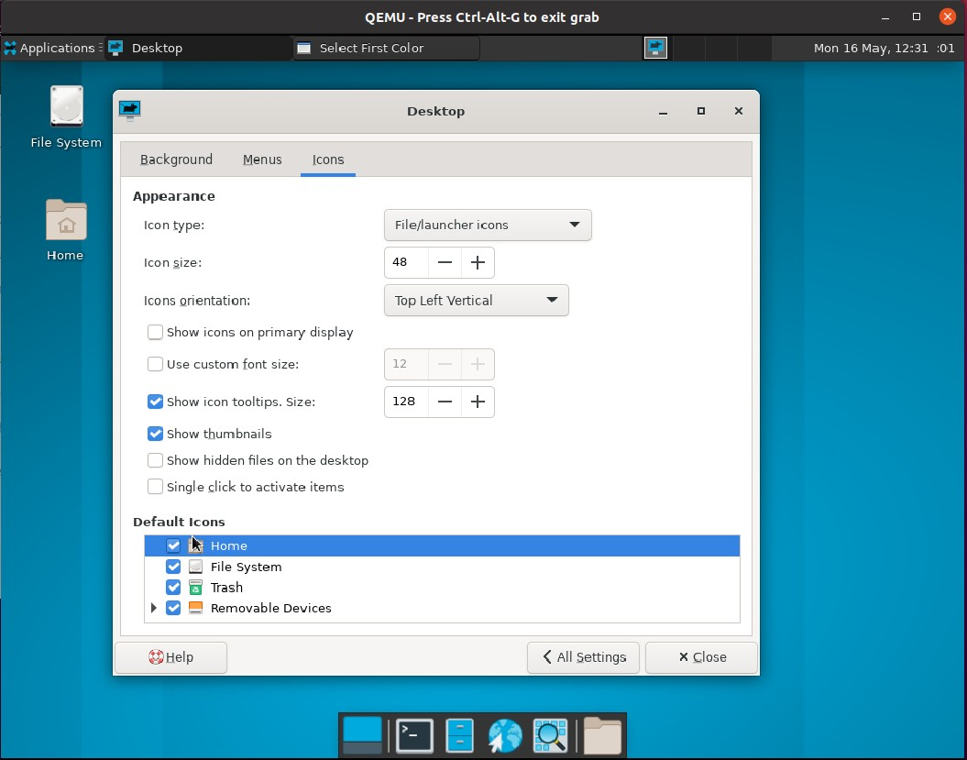测试“Default Icons”

单击“All Settings”返回

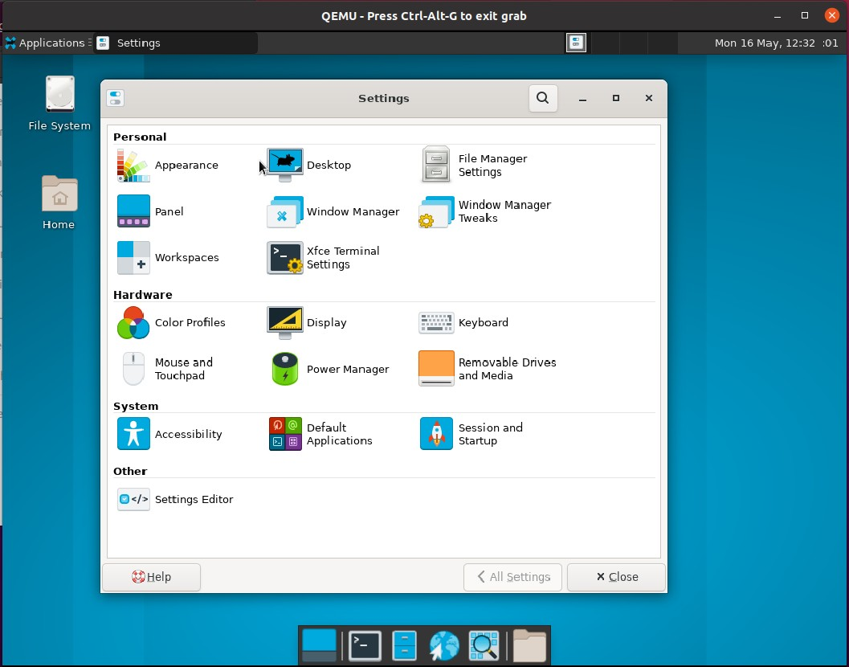

**4 、File Manager Settings功能测试**

### 双击“File Manager Settings”

测试“Display”栏

测试“Default View”

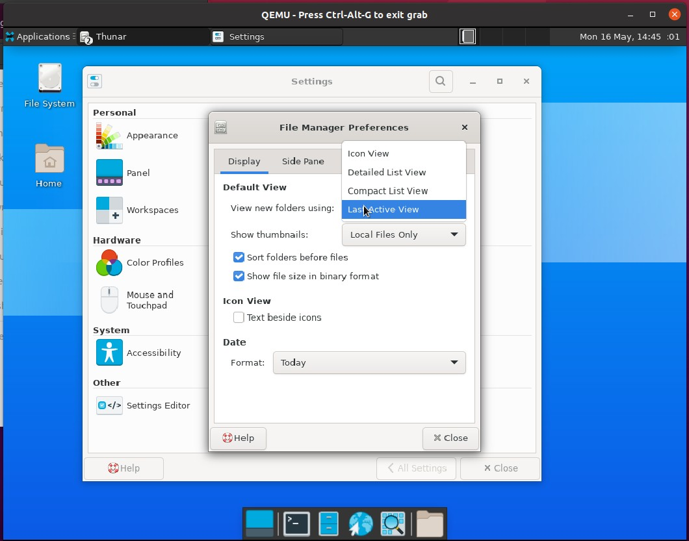

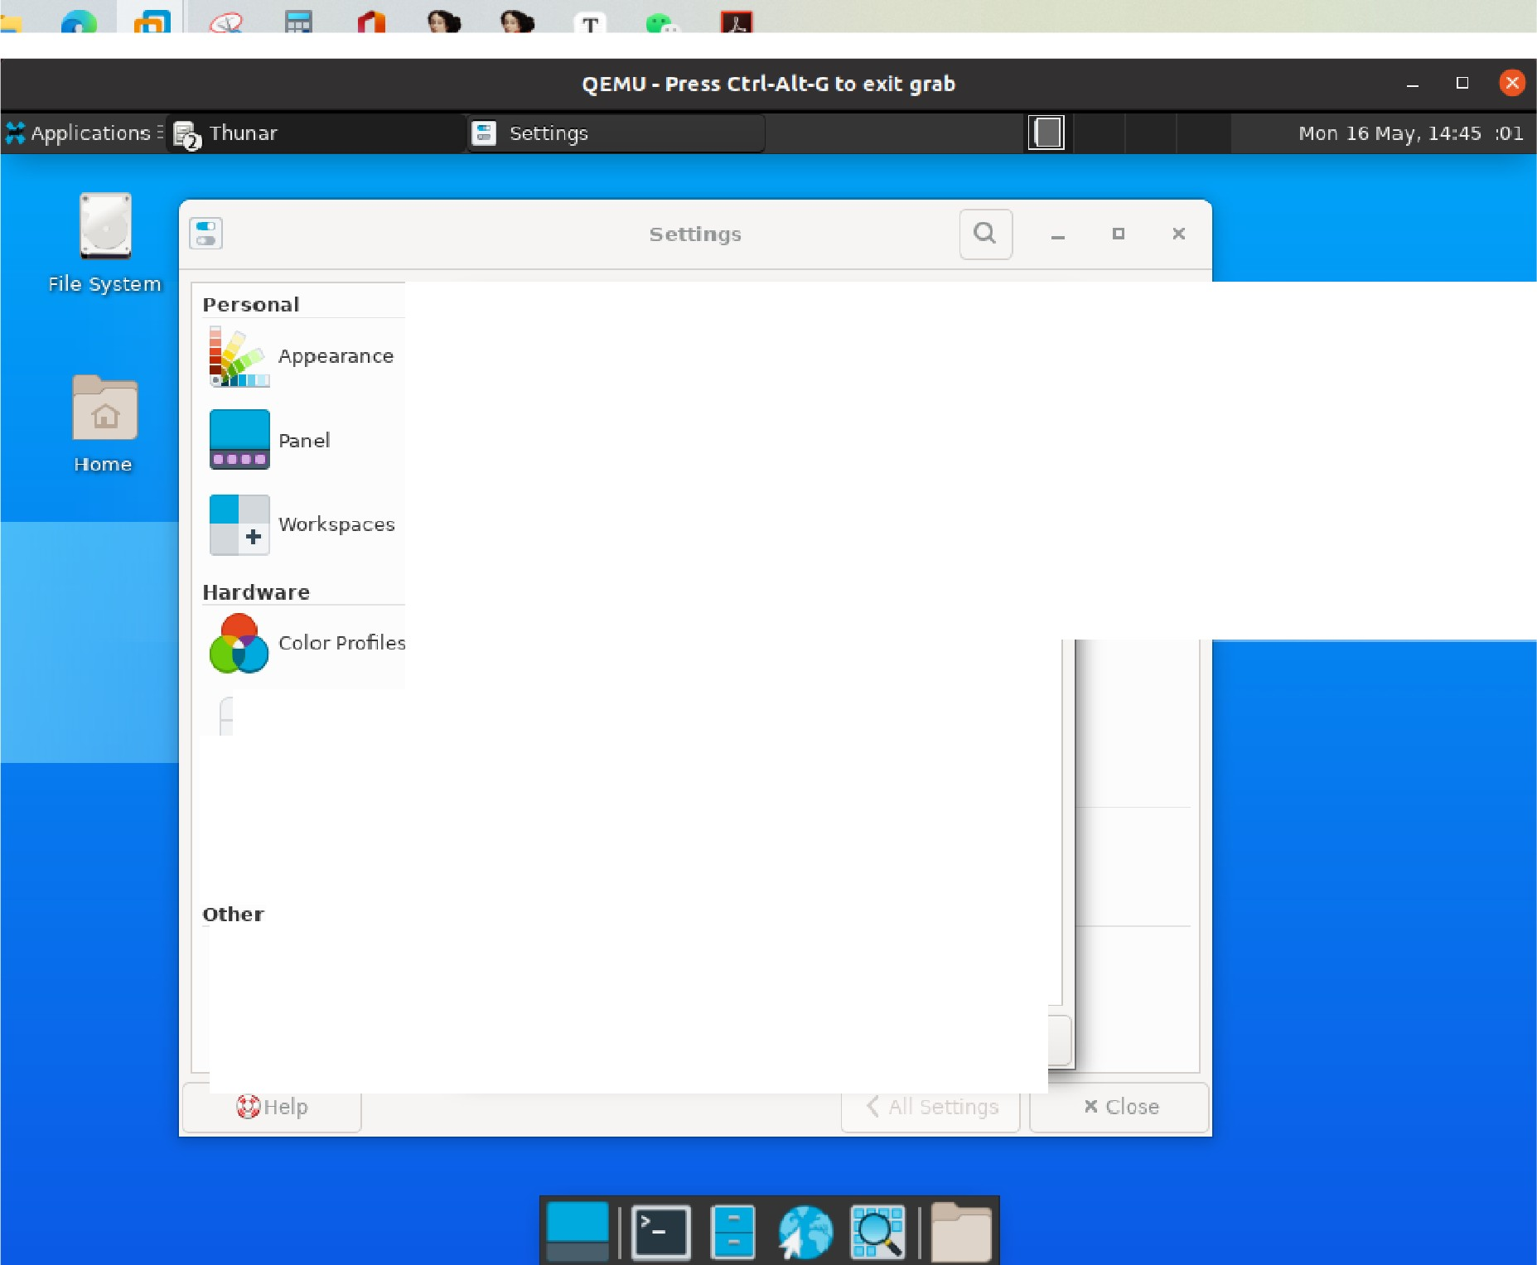

File Manilger Preferences

Dis p lay

Side Pane

Behavior

Advanced

Default View

Vie w new folde rs us i ng: Last Active View

Show thumbn 刮 s :

Local Files Only

Sort f-o lde rsh.before files

show file size i n bi n 可 y format

l

Mouse and Touchpad

System

日Access 心 lity

Icon View

0 Text besid,e c ons Date

Fonnat: Today

D •/ Sett i ngs Editor

Hel p

IC Clase

x

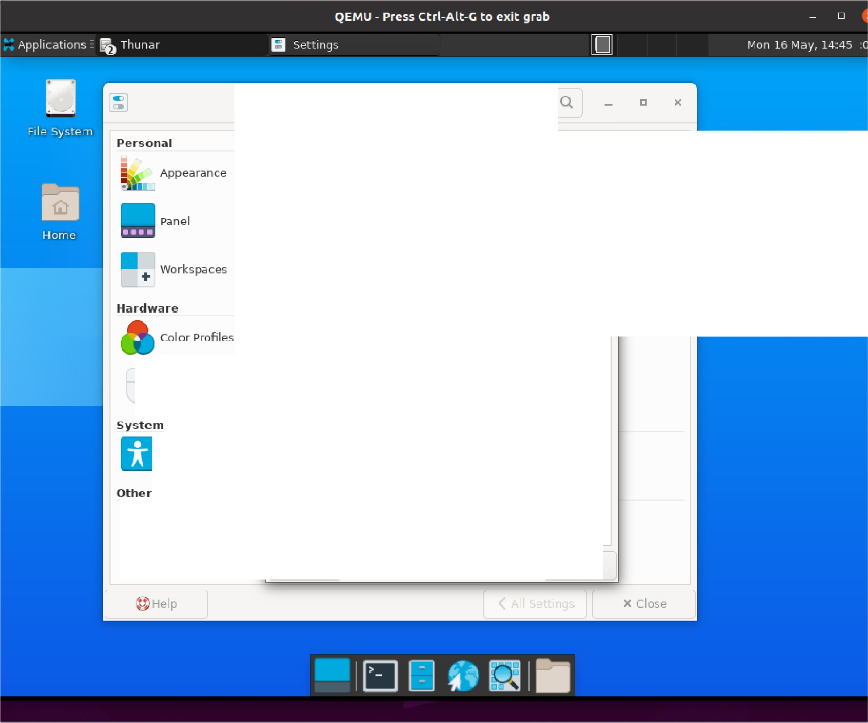

Settings

File Manager Pref.erences)(

Display

Side Pane Behavior Advanced

Default View

View new fol d e rs us i ng: t ·Neve 「 一

show thumbna ils:

＿

l

Mouse and Touch pad

日Access 心 li ty

口 Sort fo lders before file Always

Cil s how 付e size in bin ary form at

Icon View

0 Text bes ide ic ons Date

Format: Today

D •/ Settings Edit or

Hel p

JC Close

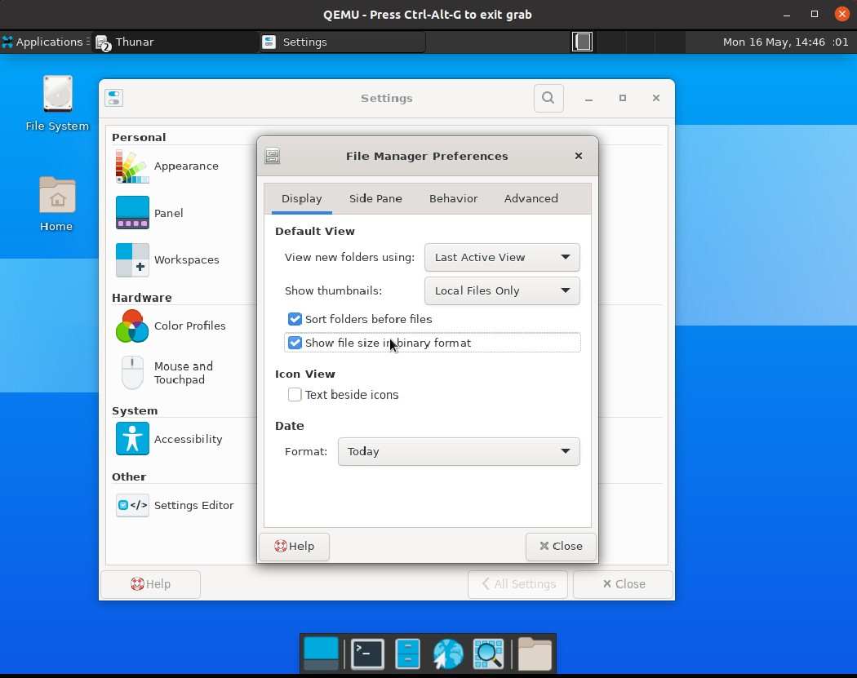

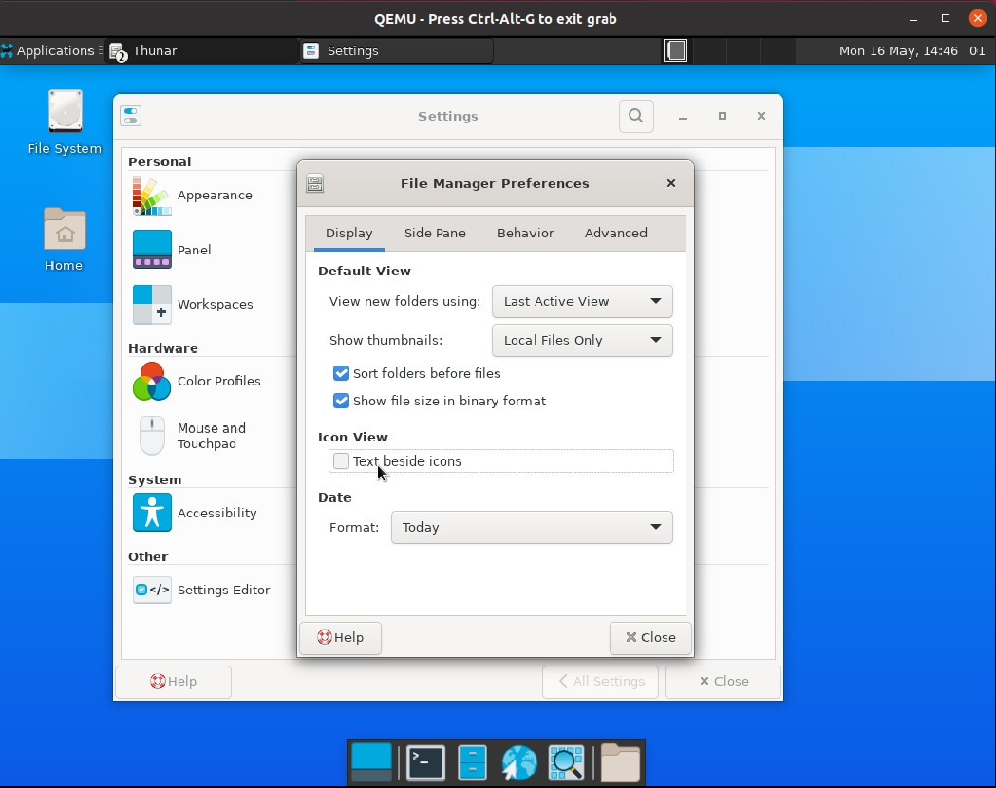测试“Icon View”

测试“Date”

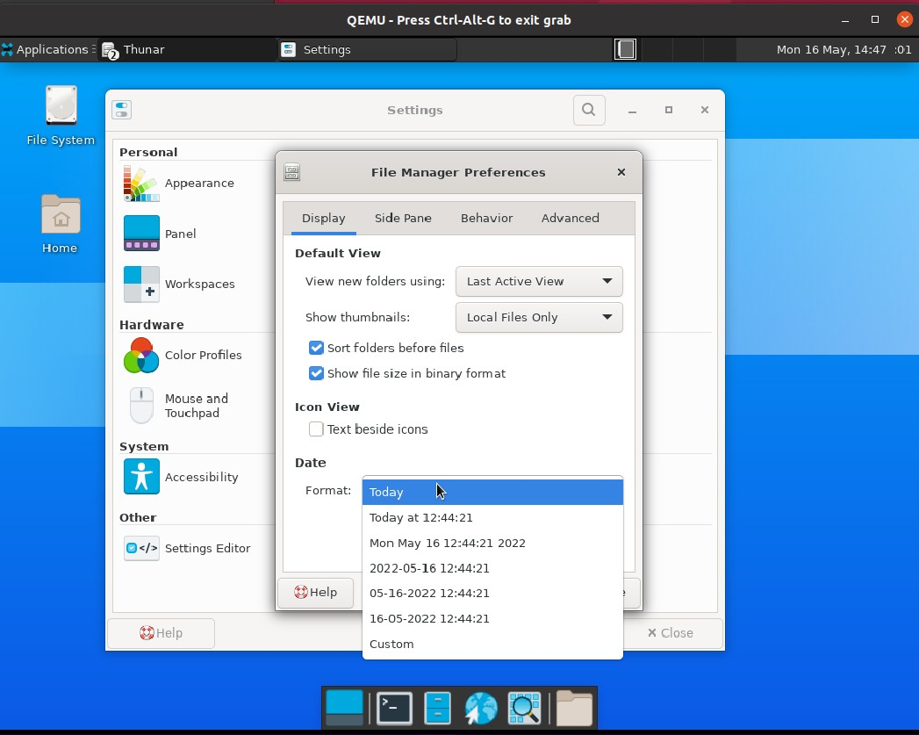

测试“Side Pane”栏

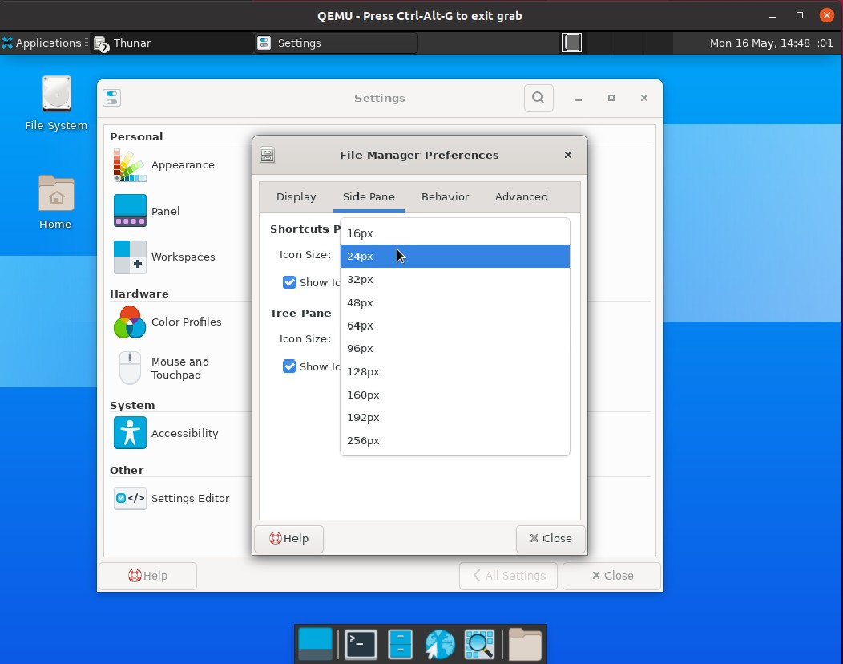测试“Shortcuts Pane”

测试“Tree Pane”

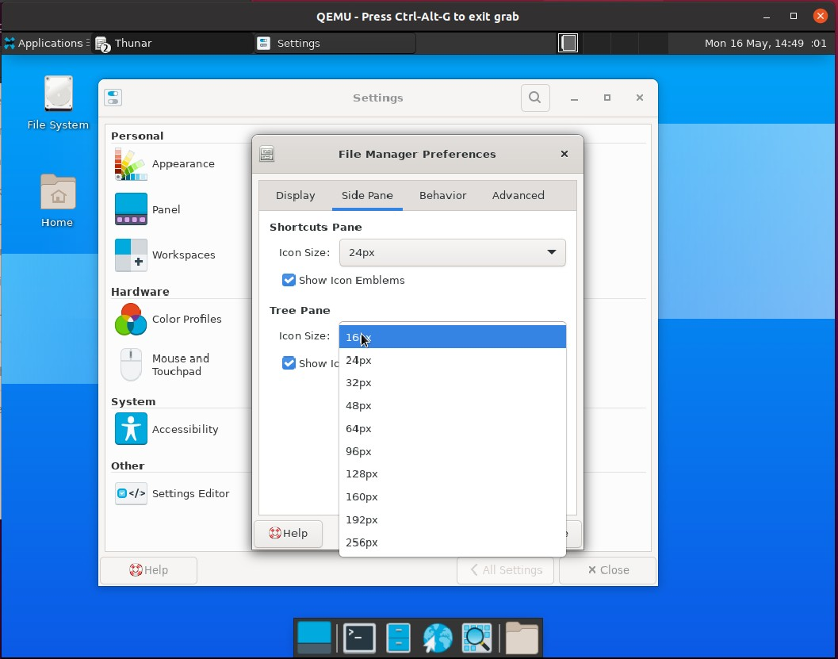

测试“Behavior”栏测试“Navigation”

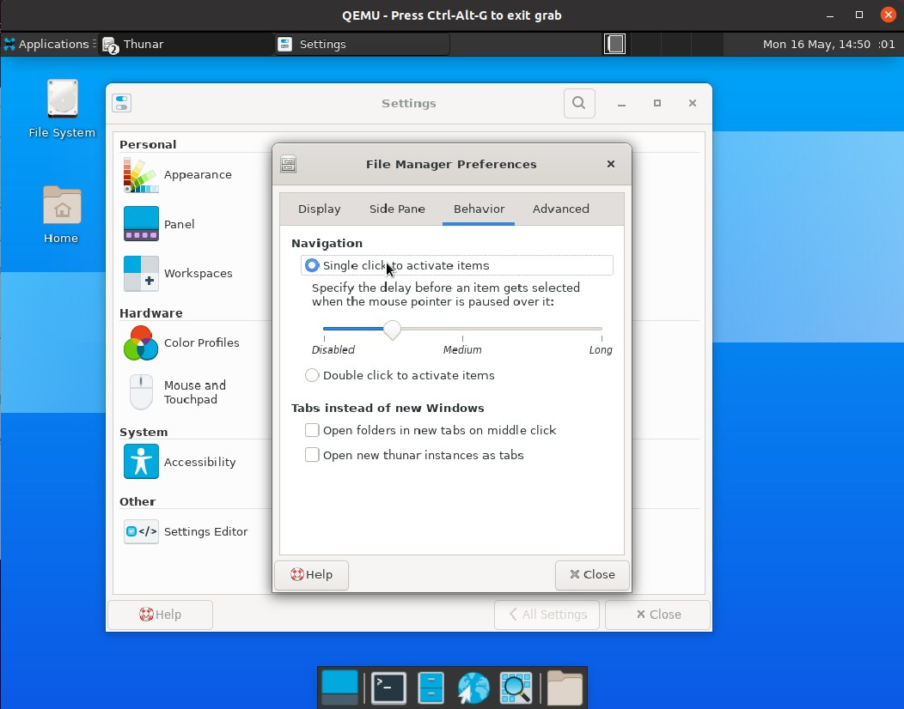

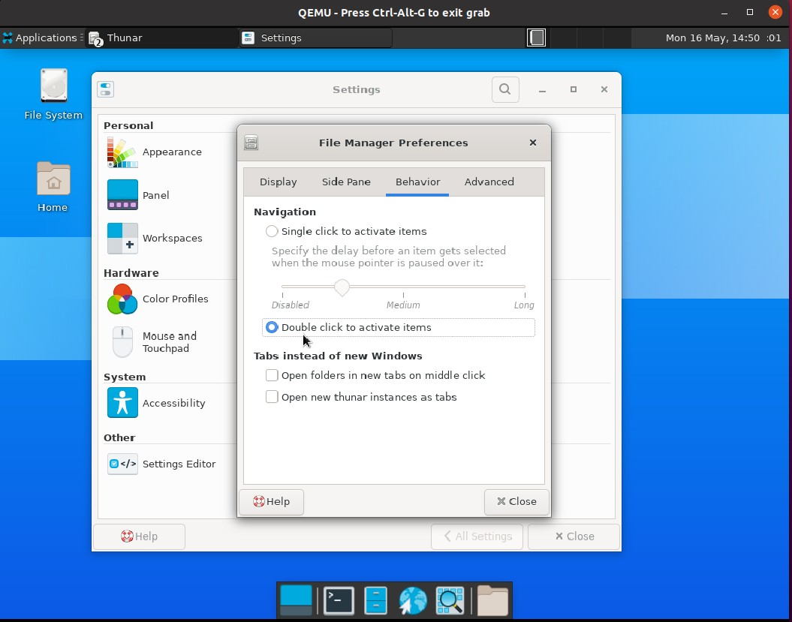

测试“Tabs instead of new Windows”

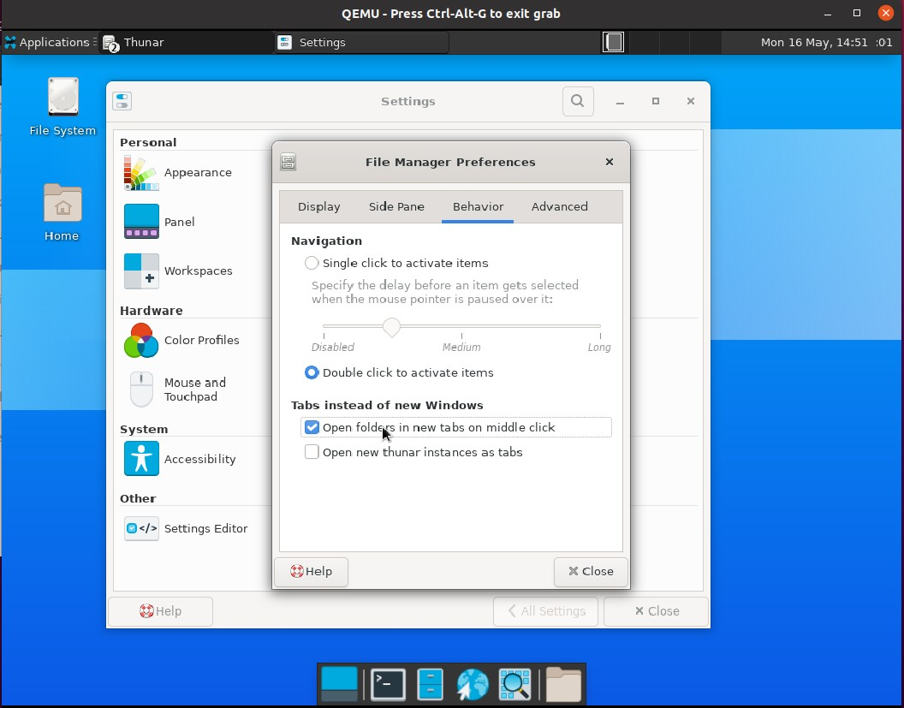

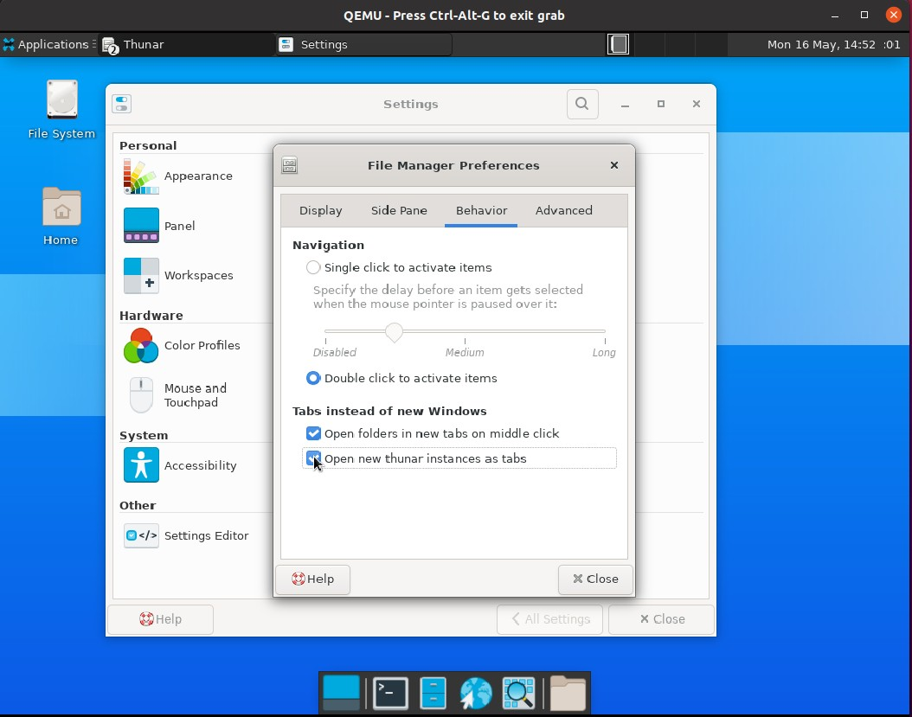

测试“Advanced”栏

测试“Folder Permissions”

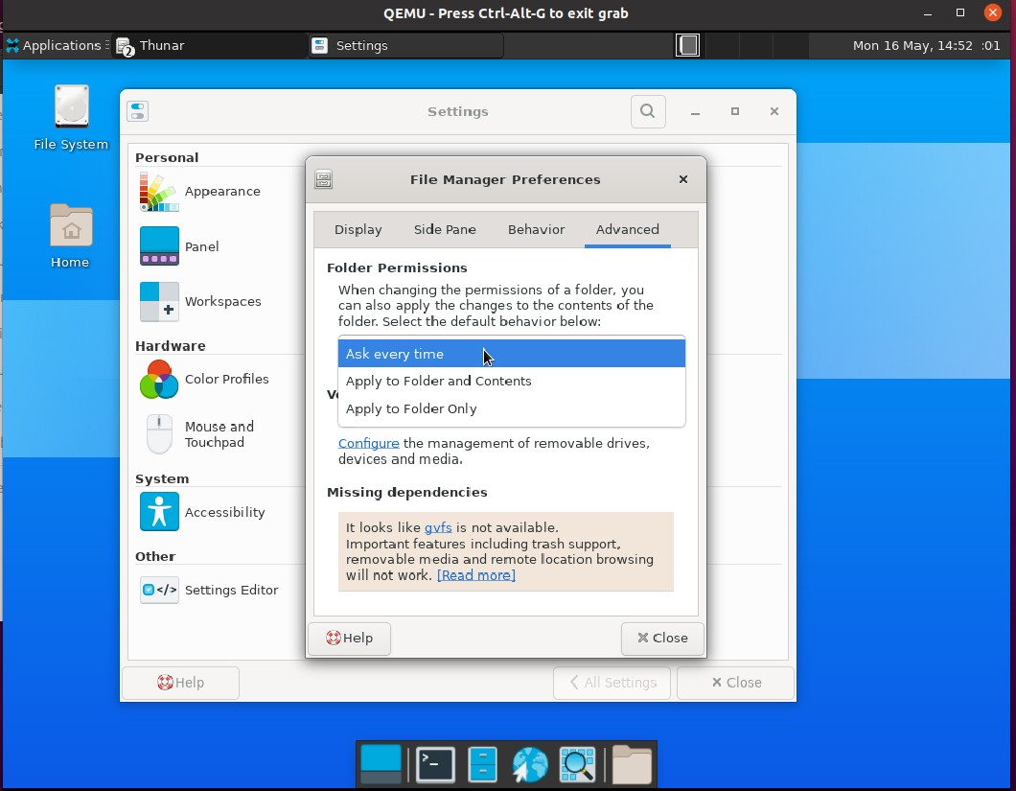

测试“Volume Management”

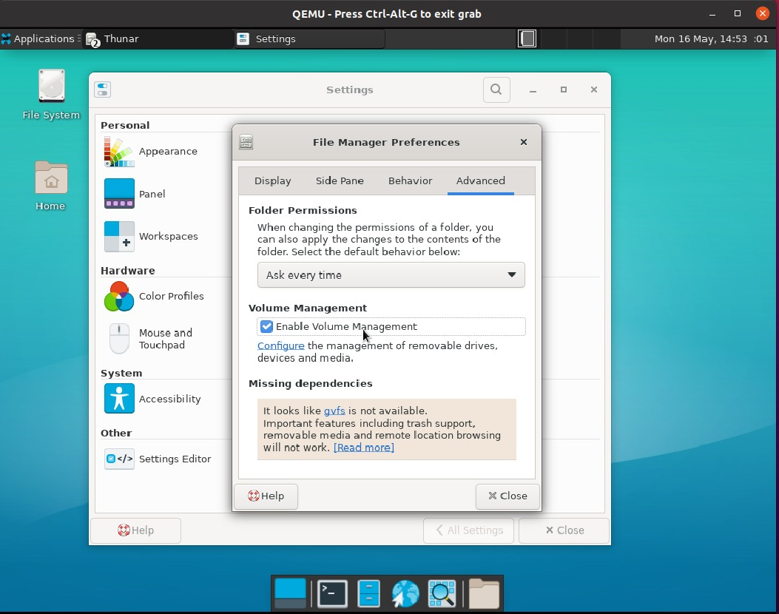

测试“Missing dependencies”

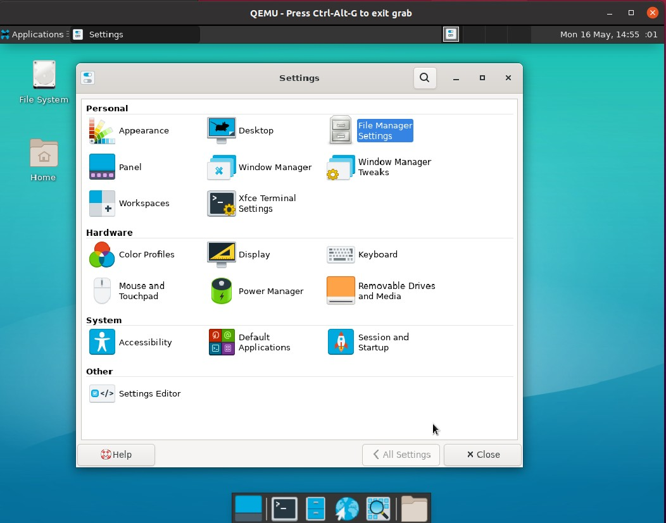单击“Close"回到Settings

到此，File Manager Settins功能测试完毕。